Creating Partnerships to Tackle Social Problems in the Mississippi Delta through Service Learning

Authors: Tracy Mims and Alinda Sledge

Service learning is an integral process in many classes taught at Delta State University; a Southern Rural Institution in the Mississippi Delta region. This region is located in the distinct northwest section of the state of Mississippi that lies between the Yazoo and Mississippi Rivers. Research shows that experiential education through service learning projects exemplifies the need to engage students by combining authentic field-based experience with classroom theory (McClam, Diambra, Buton, Fuss & Daniel, 2008). This article highlights the fundamentals of two service learning classes taught within Delta State University’s Department of Social Work. Moreover, implications and suggestions for the implementation of service learning at comparable institutions are discussed.

Whether it is hot or cold outside in the Mississippi Delta poverty subsist at an extremely high rate in this region of the country. Consequently, the social work department at Delta State University embarks upon volunteerism as being a hallmark in helping to rectify many of the social ills within reach. In developing the syllabi, we understand the importance of planning and having buy-in from the students, faculty and community organizations. The assignments are rigorous and exceedingly structured; motivating the student through inclusiveness to have a successful learning experience. Manzo (2008) states that students involved in service-learning programs report a higher interest in their coursework and are more motivated to do well in school.

The service learning courses are electives open to all students in the University. In course one, students have assigned volunteer experiences in Social Welfare organizations in the Delta and are required to attend weekly seminar on community resources. An example of an assignment is students are required to explicate their volunteer experience via lyrics of a song. This is done by exploring and connecting their personal perspective of the agency to the song through writing and classroom presentation. Subsequently, an inventory is compiled to look for recurring themes across student presentations and there is dialogue about the similarities and differences crosswise agencies/volunteer settings. Fundamentally, students identify the skills, tasks and procedures for successful interaction with the population they are dealing with through on site exploration and discussion in the classroom. Students also prepare Venn diagrams to give visuals to the group and to provide in-depth discussion about impoverished issues in the Mississippi Delta. An overarching objective of the class is that students will qualitatively document their experience through the use of a structured set of open-ended questions. Before the expiration of the semester course, students can articulate the constructs of the Delta region through the lens of social, economic and cultural components.
In course two, students are required to attend weekly seminar on community resources and also engage in 42 hours of volunteer work with Habitat for Humanity. Substandard housing in the Mississippi Delta is a plethora. Many students enroll in this class with a phobia that they can not manage tools to build a house. However, as time passes they begin to network with other community leaders, Habitat for Humanity site leaders and their colleagues and their level of self-confidence heightens tremendously. Many students indicate that this experience will last a lifetime and while volunteering they were an intrinsic part of the helping process to transition a family into a decent and affordable home. Students said that they discovered a high level of self-efficacy through autonomy and felt a profound level of motivation and achievement.

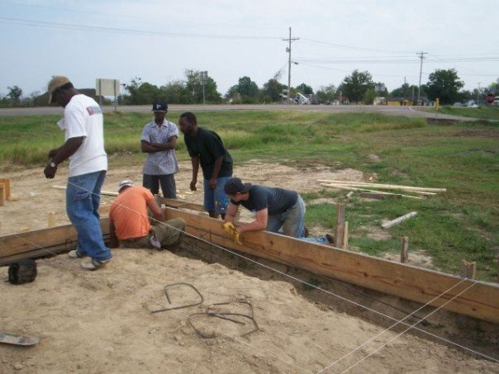

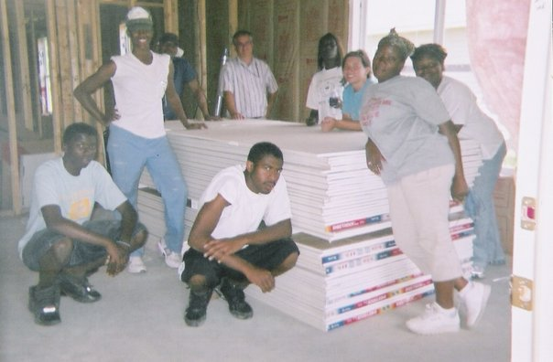

Service learning implies that there is continued conversation about the importance of humanity through in-kind service. Parents, family, friends, educators and others become more aware of services that are available through student collaboration with community agencies. Within our department, partnerships have increased significantly in this rural community after the implementation of service learning classes. As a result of these partnerships, we are able to help effect organizational policies and organizational resources that impact families and children through empowering our students to increase community awareness of economic and social problems. Higher education institutions can be the centerpiece in establishing positive community relationships and make a difference through service learning. These distinctive service learning classes can be implemented at universities across the Nation and you will too see the noticeable difference in the rapport with your community.

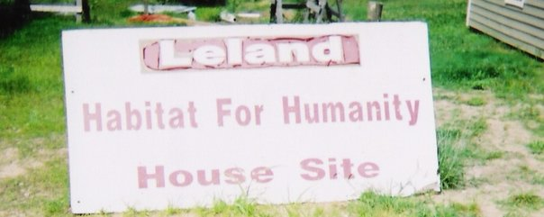

“Well you know Habitat is the class for you if you need help… it showed me how I can give to the public. It afforded me a chance to help out those in need and see families move into a decent home … sign up for Habitat and it will make you a better person not only in the classroom but on the inside as well”. Dreifus Smith

“Thanks to all who joined the class! It is great … and also you get to make a difference. All you have to do is sacrifice a little time to make a world of difference!” Taaka Cash

