During the summer of 2008, Instructor Yvonne Tomek attended the University of Iowa Summer Writing Festival to study in a workshop on poetry taught by Faith Adeile. She also had a book of personal poems wrote in bilingual form, English and French, published by Northwoods Press in Thomaston, Maine. It has a tape of selected poems that accompanies it recorded with the DMI, under the direction of Mike Iacopelli, Delta State University.

Dr. Paulette Meikle, Assistant Professor of Sociology and Community Development accompanied a group of four students from the Division of Social Sciences to the beautiful tropical island of Grenada West Indies. Students traveled there to satisfy the requirements of her course entitled “Community Development in an International Setting”, trained 74 rural folks in information technology (IT), and attended classes at St George’s University. Dr Meikle conducted a workshop for the GREP’s community officers and leaders from rural Community Based Management Organizations entitled “Team Skills in Community Organizations.” They spent just over a month in the Spice Isle: Grenada West Indies in summer 2008.

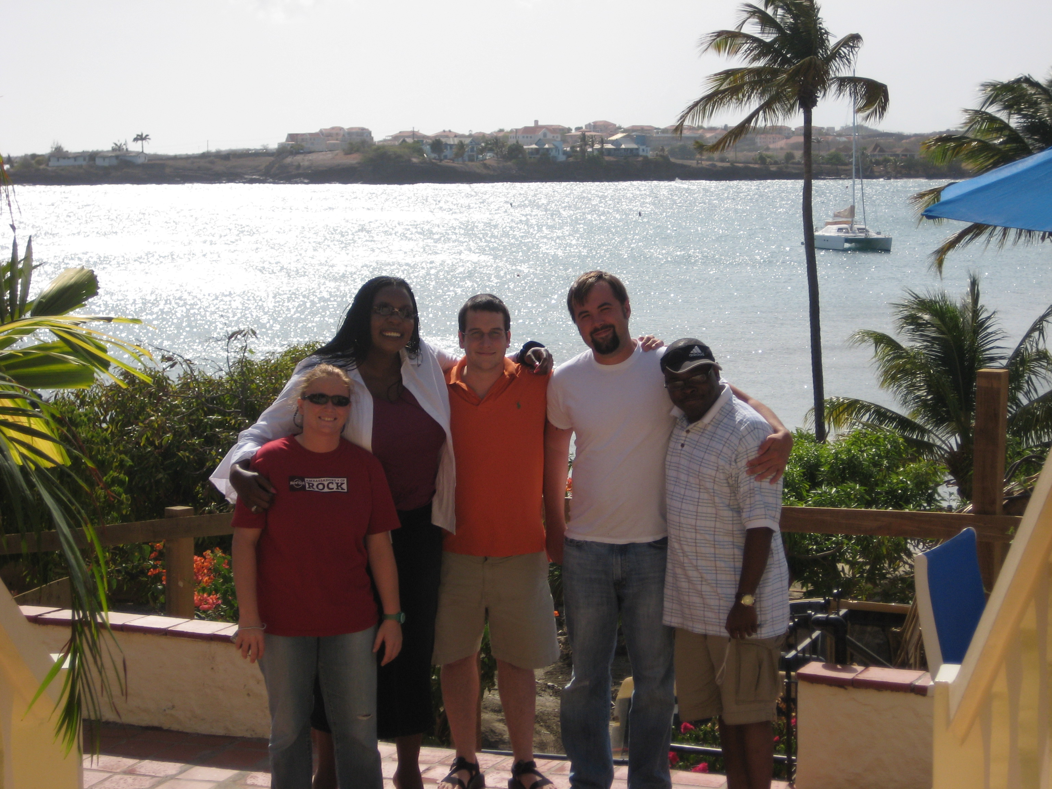
L-R: Carley Jefcoat, Dr. Meikle, Zach Tatum, Cody Moore and
Emanuel Edmond at St George’s University Faculty Club.

Robyn Moore, Assistant Professor of Art, would like to announce the publication of "Time Out of Mind", a book of photographs and etchings from 2004-2008. The book will be available through blurb.com in October. She was also awarded a DSU faculty mini grant in support of her new film "The Miracle of Remaining Alive", an experimental documentary short to be released in November.

Dr. Tracy Mims, Assistant Professor of Social Work and Director of Field Instruction, presented at the International Conference on Diversity in Organizations, Communities and Nations in Montreal, Canada this summer. He also has an international peer reviewed publication entitled “Male Student Perception of Academic Persistence at a Predominantly White Southern Rural University (WSRU)” in the International Journal of Diversity in Organizations, Communities and Nations, Vol. 8, www.diversity-journal.com.

The Cleveland Summer Concert Band was reestablished this summer after at least a decade’s hiatus.
Organized by Cleveland resident and saxophonist Rogers Varner, and DSU Band Director Dr. John
Wojcik,the band rehearsed on Wednesday evening during June. A performance was held on July 2 in
Ewing Hall’s Jacob Conference Center. The festivities ended with an ice cream social.

Dr. John Wojcik was selected to attend a workshop held by the Mississippi Alliance for Arts Education held at the University of Mississippi campus, July 21-22. The workshop offered ways to incorporate music and art into all subjects studied at PreK-12 levels.

Dr. Douglas Mark, Assistant Professor of Music, served as Principal Trombone in the 8th season of the Mississippi Wind Symphony this past summer. The concert season consisted of two themed programs. The first program, entitled 'European Euphoria', featured works by Suppe, Holst and Dahl. The second program, called 'Pulsating Percussion', showcased members of the ensemble's percussion section.

Dr. Larry Bradford, DSU Assistant Band Director and Yamaha Performing Artist was the guest clinician for the Sounds of Summer camp held at Hinds Community College in June 2008. This camp sponsored by the Yamaha Corporation of America and Mississippi Music, hosted 45 of Mississippi’s best percussionists in a 2-day camp designed to improve their rudimental approach to drumming. In addition, Dr. Bradford was featured as guest soloist with the Mississippi Winds at the conclusion of the camp.

This summer, Dr. James Tomek, passed comprehensive exams. This grants him the go-ahead to write a thesis in pursuit of an MA Degree in Theology at Spring Hill College. Currently, he has a PhD in Literature, but the theology studies are an addition to his interests in literature. Dr. Tomek states, “the Master of Arts degree is a step higher than the Master of Theological Studies that I already have”.

You can discover more about a person in an hour of play than in a year of conversation. -Plato

A message from the Editor, Dr. Tracy Mims
Welcome! The Arts & Sciences E-newsletter presents a wealth of news and information from around the College of Arts & Sciences. Our goal is to create a forum of exchange to better inform you of the activities within the various departments and divisions and keep you abreast of the latest news and items of interest.

In this month's edition, Faculty News items are listed in alphabetical order by the faculty member's department/division beginning with the Delta Music Institute, Geospatial Information Technologies Center, the Department of History, the Division of Languages and Literature, the Department of Mathematics, the Department of Music, the Division of Social Sciences, the Department of Social Work, the Department of Speech and Hearing Sciences, the Department of Art, the Division of Biological and Physical Sciences. The Faculty News items will rotate each month beginning with the Division of Biological and Physical Sciences for the month of October.

