MERRY CHRISTMAS
SOCIAL WORK CLUB
CHRISTMAS PARTY 2008

WHERE: CAPPS SEMINAR ROOM
WHEN: DEC. 4, 2008
WHY: TO CELEBRATE THE SEASON
12 NOON

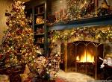

GET READY
FOR
FUN GAMES, HOLIDAY FOOD, MUSIC AND SONGS

