 | Delta State University  Human Resource Management  Kent Wyatt Hall 249  Cleveland, MS 38733  Phone: (662) 846-4035 • Fax: (662) 846-4025  “Developing Partnerships Within the University”

DEPARTMENTAL USER’S GUIDE

Delta State University
Hiring System



Updated 3/14/2017

INTRODUCTION

Welcome to the Delta State University Recruitment System. This system was established to
maintain our automated internet based system for processing requisitions and accepting
applications for employment.

This system will be used to:

- Create and submit position posting to Human Resources
- View Applicants from your Posting
- Notify HR of your decision to hire
- Complete Recruitment Report
- Submit Hiring Proposal

The system is designed to benefit you by facilitating:
- Faster processing of employment information
- Up-to-date access to information regarding all of your Postings
- More detailed screening of Applicants' qualifications

Table of Contents

CREATING A POSTING…………………………………………………………………….…. 3
Create New Position……………………………………………………………………. 4
Search Committee Members………………………………………………………..…. 6
Posting Specific Questions………………………………………………….……….…. 7
Reference Letters…………………………………………………………….……….…. 8
Applicant Documents………………………………………………………………..….. 9
Posting Documents………………………………………………………………..……. 9
Posting Completed/Submit for Approval……………………………………………… 10

VIEWING APPLICANTS FROM YOUR POSTING…………………………………..……. 10

MANAGE APPLICANT POOL…………………………………….……………………….…. 11

HIRING PROPOSALS……………………………………….………………………………… 13

REVIEW OF STEPS …………………………….…………………………………………….. 15

Create Job Posting:
Access the PeopleAdmin site by going to https://deltastate.peopleadmin.com/hr/
(Sample screenshot of the form below)

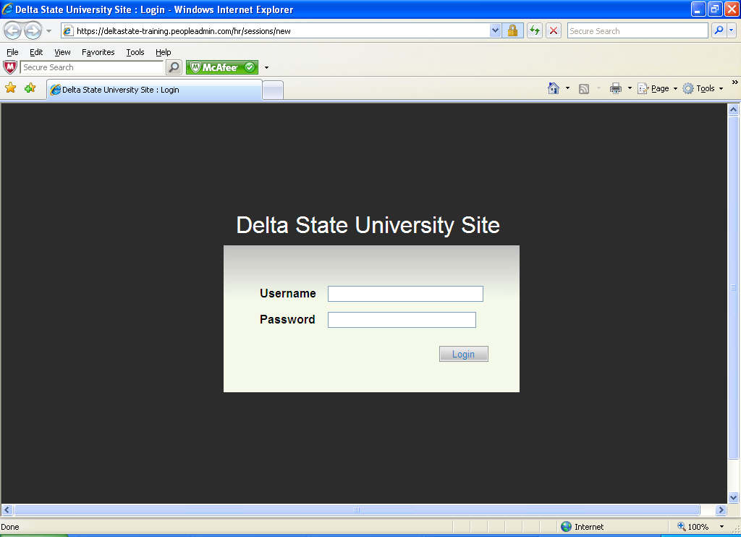
Type in your Username and your Current Delta State Log In Password.

You will now be logged on to our Online Recruitment System.
(Sample screenshot)
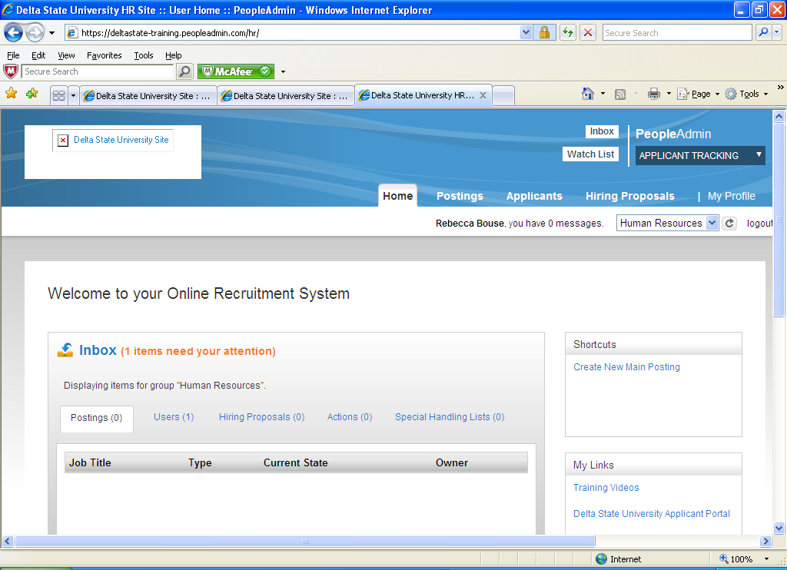
To create of new job posting: Click on Postings/Main on middle/top of screen. Once in site, click Orange Create New Posting button on top left side of screen. (Sample screenshot of the form below)

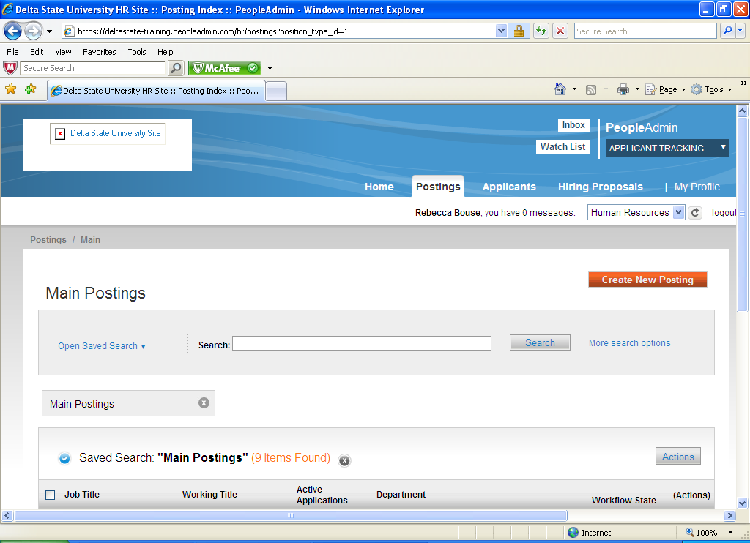

You need to decide how you would like to create your new posting. You will pick from the following:
- Create from Posting Type (new position never posted before)
- Create from Title (feature not working at this time)
- Create from Posting (search by browsing postings previously posted)
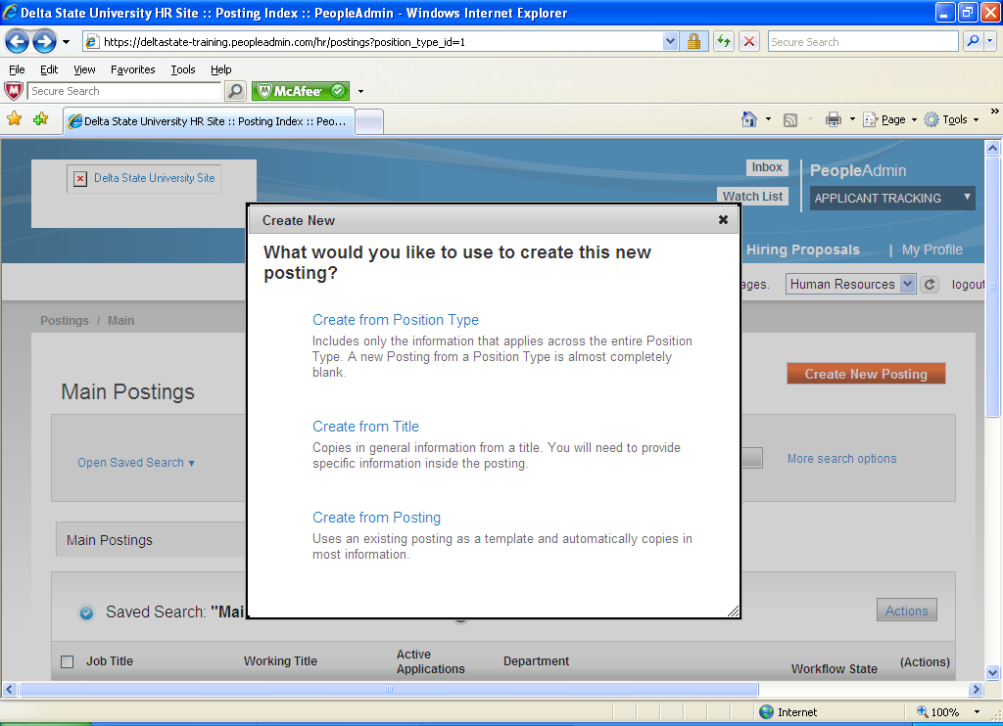
If you select “Create from Position Type” you will now type in Job Title. Your Organizational Division and Department will already be filled in. If you are pulling from a position already posted select “Create Posting from this Posting”. (See example below)
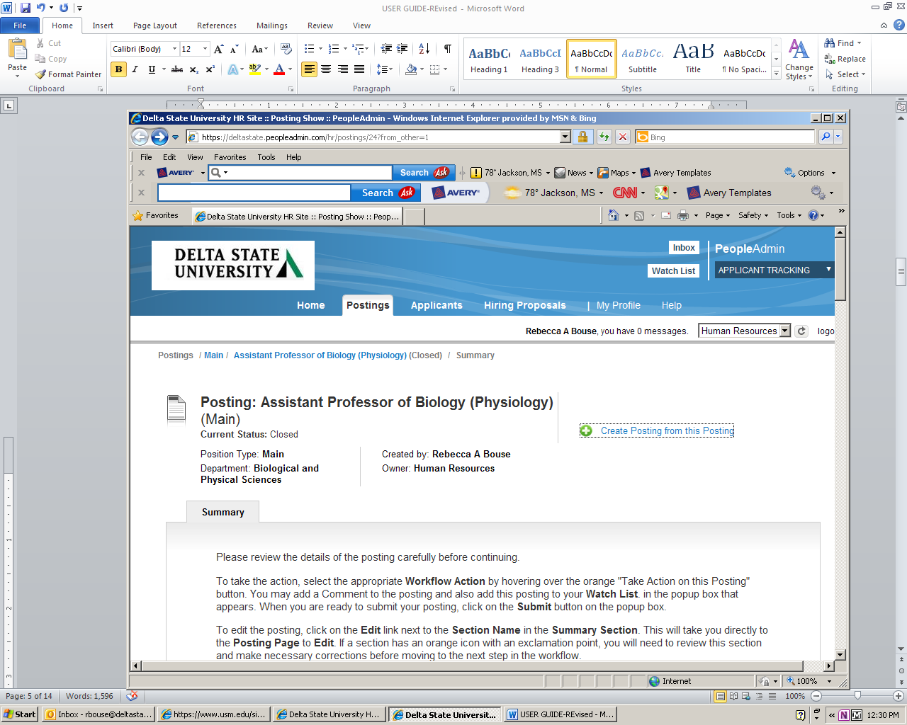
To create a Posting, first complete the information on this screen, then click the Next button or select the page in the left hand navigation menu. Proceed through all sections completing all necessary information. To submit the Posting to Human Resources, you must go to the Posting Summary Page by clicking on the Next button until you reach the Posting Summary Page or select Posting Summary Page from the left navigation menu. Once a summary page appears, hover your mouse over the orange Action button for a list of possible approval step options. The posting must go through the proper approval chain depending on department until it reaches Human Resources. Human Resources will review/approve and post position.
(Sample screenshot on next page)
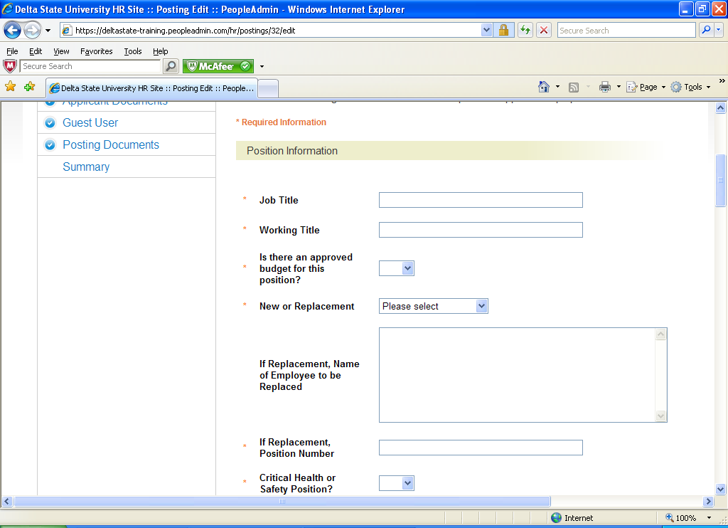
Fill in all the position information. This can be saved at any time as a draft to work on later. As long as it is in draft mode you will be able to make changes.
When you go to the next page you have the option to select Search Committee Members. If they are not located in the system you can request a new search committee member by creating a new user account. (Sample screenshot below)
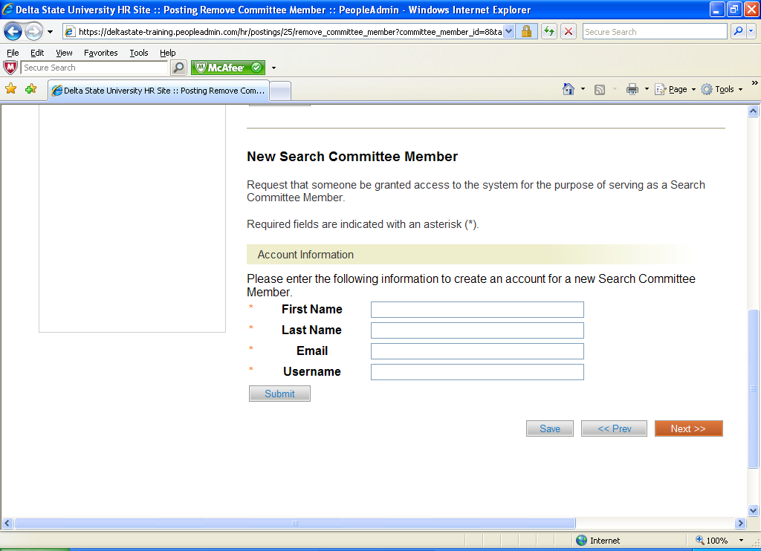
Click on the Next button.

You are now at the Rank Criteria section: You may select or add questions to be used by search committee members for ranking applicants. (Would be used mostly for faculty searches)
(Sample screenshot below)

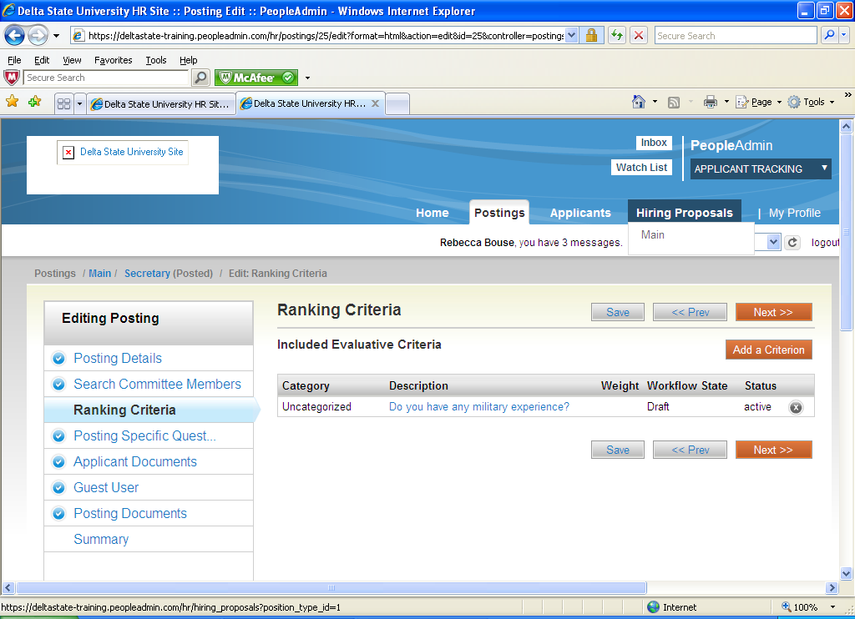

Click on the Next button.

Posting Specific Questions:

- To add a New Posting Questions: Click on the button labeled "Add a Question".
- You can add an existing question.
- You can Assign Points or Disqualifying Responses: Click on the question that has been added and a dropdown menu will appear where points and disqualifying responses can be associated to the posting question.
- Posting Question Options: Once questions have been added to the posting, you will see a column of checkboxes to the left of each question; checking these boxes will make a question required.

(Sample screenshot on next page)

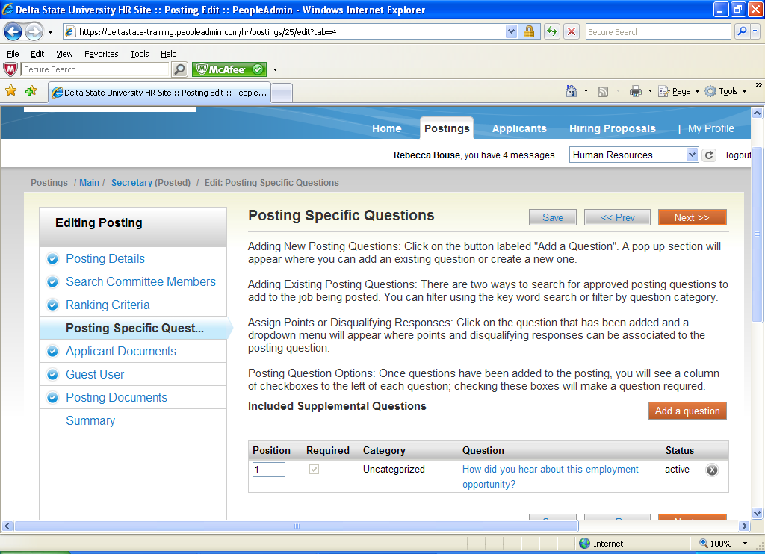

Click on the Next button.

Reference Letters
If you would like to request letters of recommendation click yes on the field shown below. Requests for letters of recommendation will automatically be generated to the references that are listed on all applications. They will be sent a link to allow them to submit letters directly to application. If you would only like letters of recommendation once an application is transitioned to phone or campus interviews, please contact Human Resources. If letters are just optional, a link will not be sent and the candidate will be responsible for uploading their own.

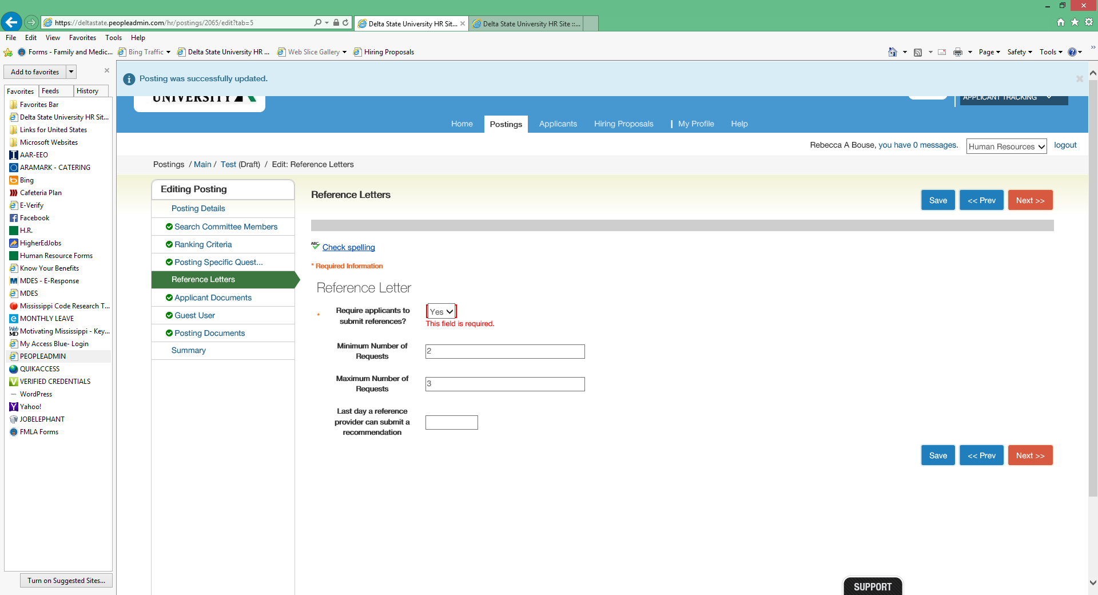
Applicant Documents:
Applicant documents can be included in the application process by selecting either optional or required. If required is selected the applicant will not be able to complete the application process unless the document(s) are included.
(Sample screenshot below)
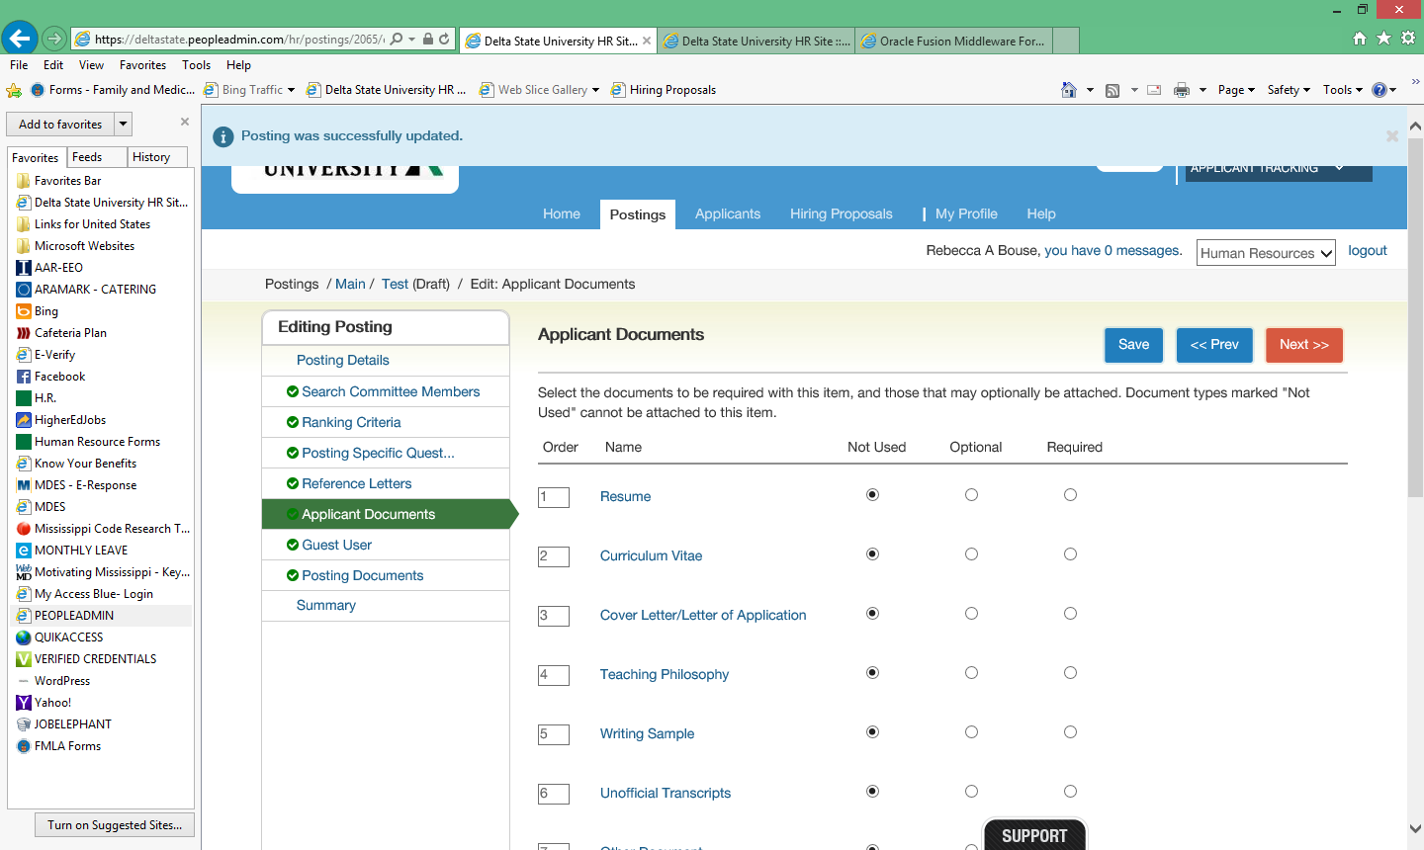
Click on the Next button.

Guest User: If you need a Guest User you can create an account. This account would be used for anyone off campus or DSU students. The Guest Users will receive a username, password and link to access posting from a system generated email once position is posted.
Posting Documents: To add a document to the posting, hover over the blue Action text link to the right of the document name.
Below is a screen shot of Documents that can be added:
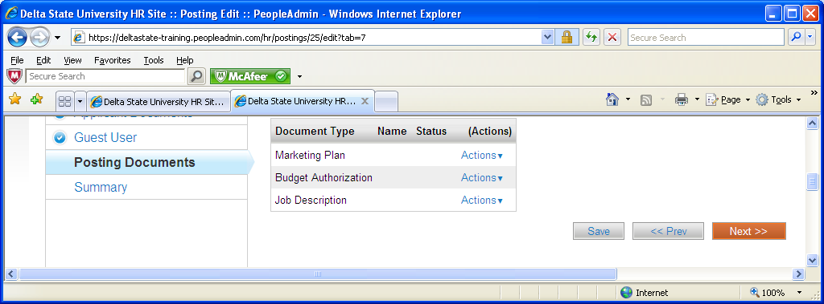
Click on the Next button. Your posting is completed. Please review the details of the posting carefully before continuing. It might be helpful to click on the See how Posting looks to Applicant button. This is what the applicant will see when searching for positions.

Posting Completed (Submit for Approvals)
Now you will click on the Orange Take Action on Posting button. (Sample screenshot below)
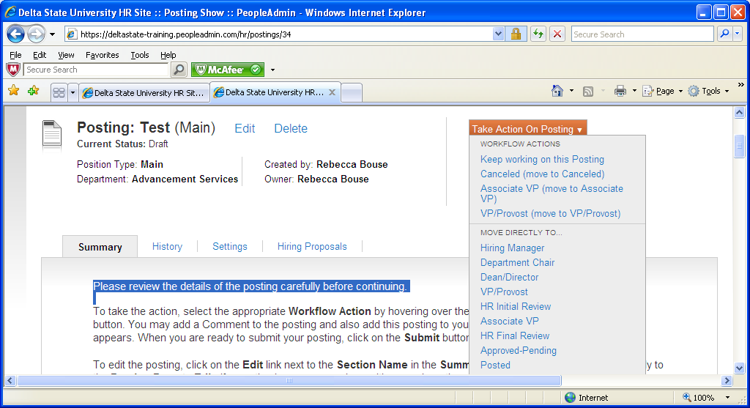
You will move posting to the next approver. It will go along the chain of approvers until it reaches Human Resources. Human Resources will approve and post to website.

The Hiring Department will now be setup to receive applications.

Reviewing Applications:

Click on your posting and move cursor to Applicants. Click on the Applicants box. You now will be able to view all the applicants that have applied by clicking on their names.

To view more than one applicant at a time just put a check by their names or a check at the top of list by Full Name to few all. Now click on the large “Actions” button on the right side and click “Down Load Applications as PDF”. This will let you view the applicant(s) application and attached requested materials. You can also print this list. (Sample on next page)

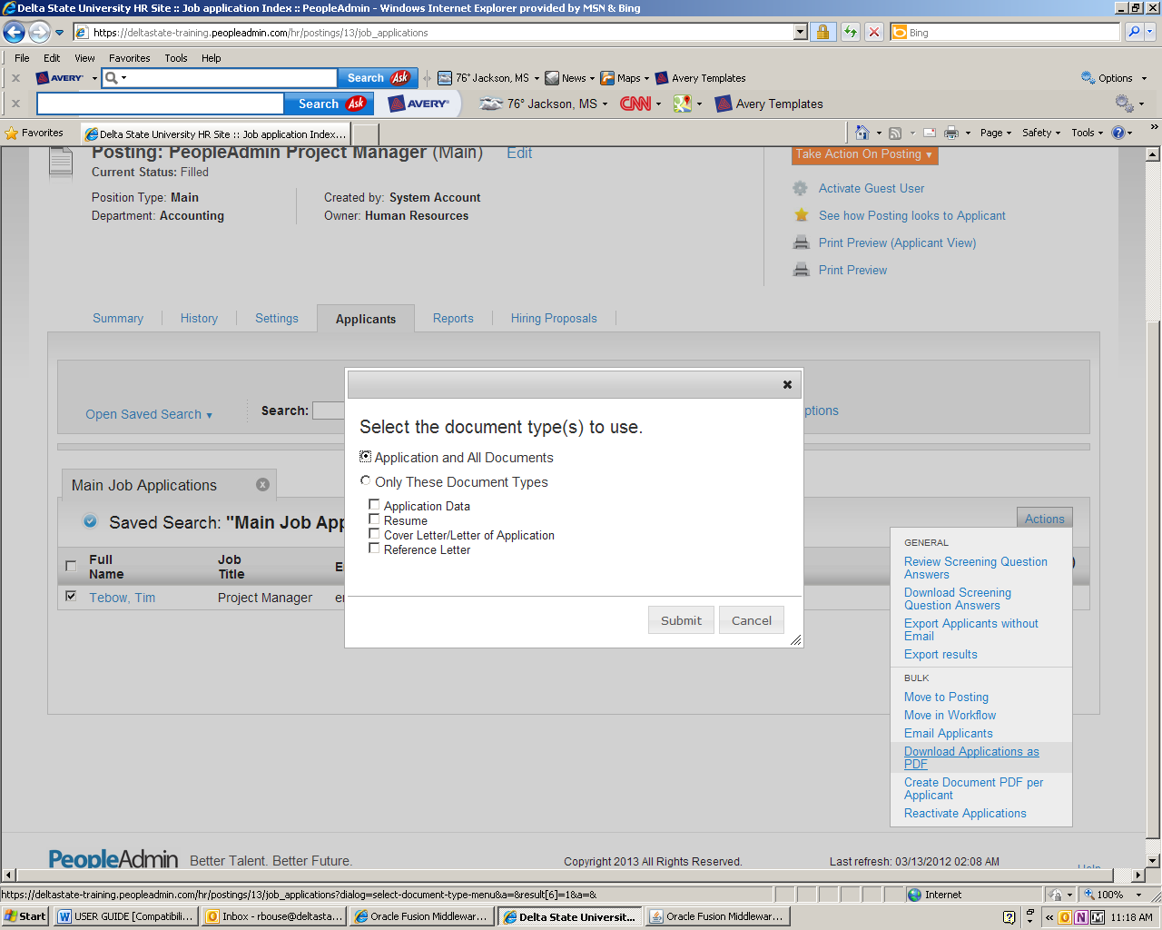

Manage Applicant Pool: To manage your applicant pool, move candidates that don’t meet requirements to Not Interview/Not Hired. This will remove them from your applicant pool and place them in the not interview/not hired category. If candidate is interviewed, move to Phone Interview/Campus Interview then Interviewed/Not Hired or Recommend for Hire. You will need to make sure your title is set at “Hiring Manager” for this to work. The applicants will be moved to a list that can be viewed at any time by doing a search function. You can do one applicant at a time by clicking on the Orange Take Action on Job Application button. (Sample screenshot on next page.)

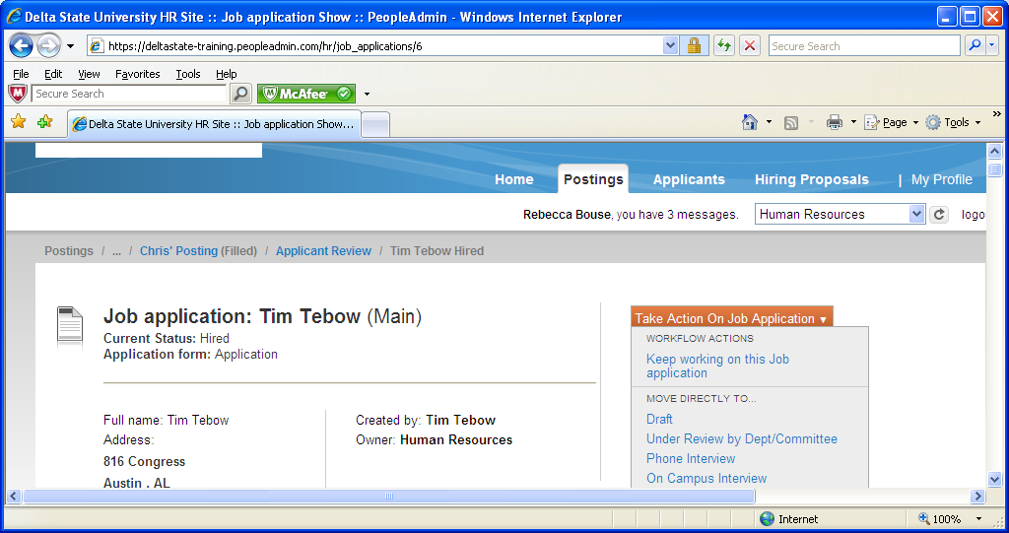

If you have a group of people in the same category you can move candidates over in bulk by putting a check in the box by their names and going to the large “Action” button on the right. Look for “Move into Workflow”.

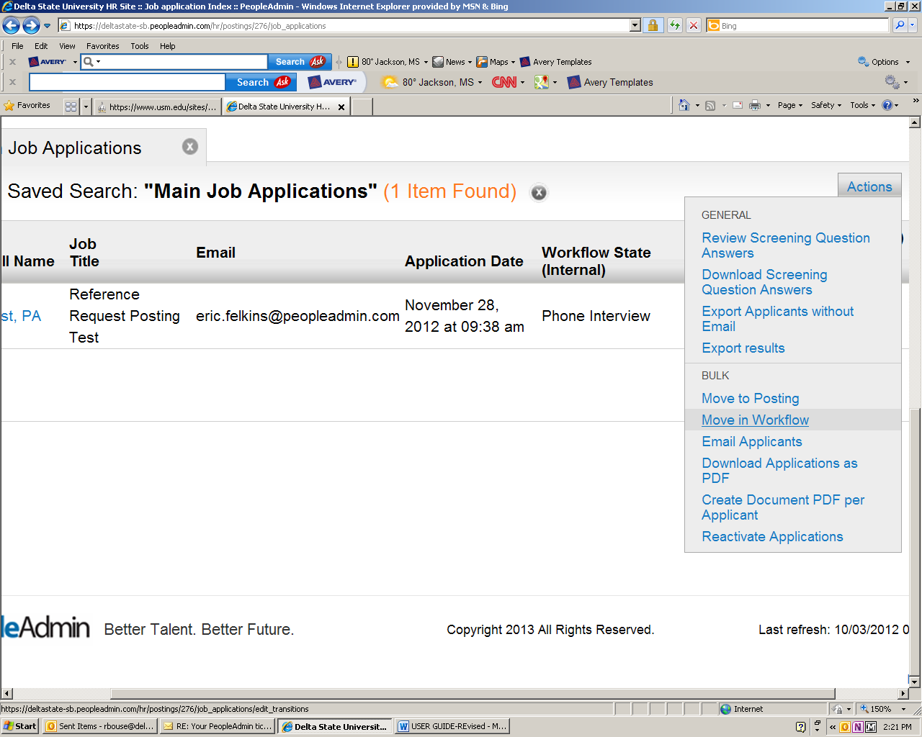

Hiring Proposal:

Once you have decided on a candidate to hire, move them to the campus interview or phone interview category by going to the orange “Take Action” button. After that you will select Recommended for Hire. Now a Hiring Proposal can be done by the Department Chair/Dean/Director.

(Sample screenshot below)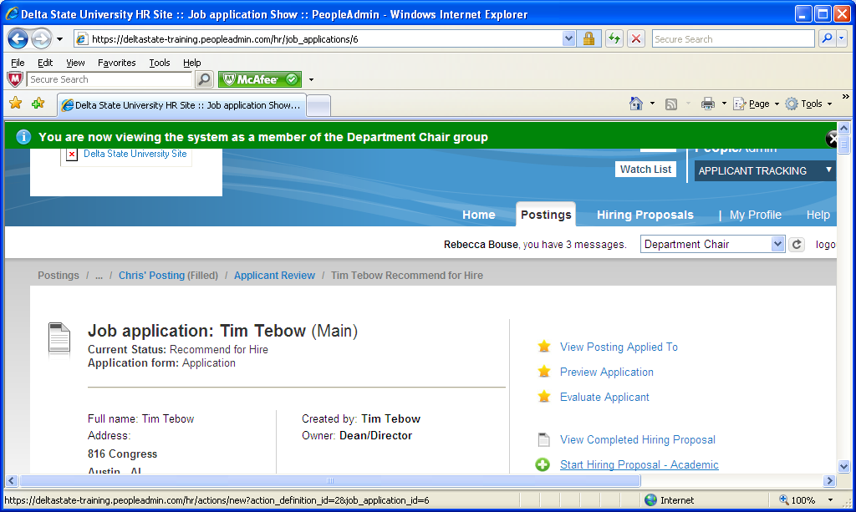

Click on Start Hiring Proposal. (Sample screenshot below)

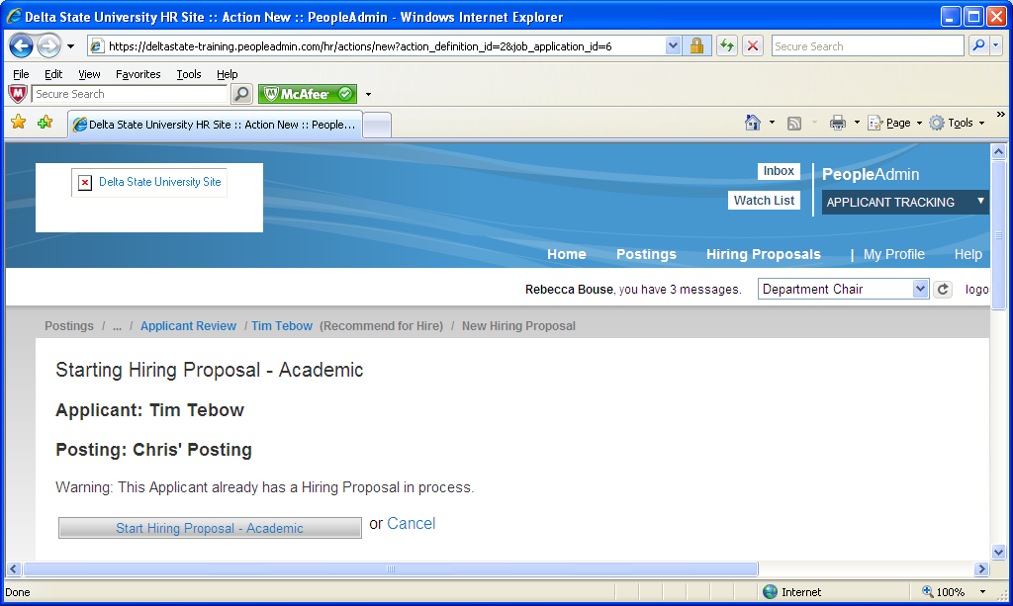
You will enter the Hiring Proposal site. Review and input salary, start date and any other information you have on the new hire.

You will now click on the Take Action on Hiring button and move to the next in line for approving.
Hiring proposal must be approved by H.R. before an offer is made. (Sample screenshot below)
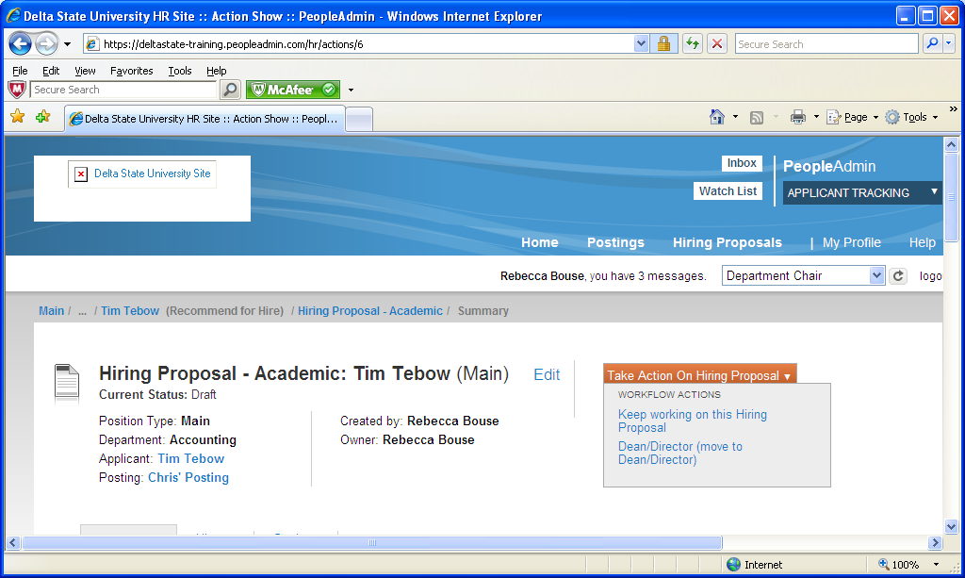

!!! Important!!!
Remember to take action on all applicants by classify them as Not Interviewed/ Not Hired or Interviewed/Not Hired. Human Resources will move position to Filled after an offer has been made/accepted. This will notify only Not interviewed/Not hired candidates by email that the position has been filled. The Department is responsible for contacting all candidates interviewed. By completing this action, you are also completing the Recruiting Report that is necessary for all positions, and affirmative action guidelines.

REVIEW OF STEPS
- Complete posting.
- Route for approval.
- H.R. will post when position is received and approved.
- You will start receiving applications directly to your posting.
- When ready to make offer, email Lisa Giger in HR with name, title of position and salary for approval.
- Make sure and follow staff hiring guidelines at located:
Hiring Procedures and Background Screenings Rev.01-17.docx

- When hire has been approved and background screening returned, start hiring proposal (Page 13)
- Please review HR hiring guidelines before making an offer.
- When approved:
  - Background check - Background checks shall be required for all new hires in regular full-time, regular part-time, benefit-eligible positions. The candidate, which are scheduled to assume their duties on or after the policy effective date. This policy excludes current University employees who are moving to a new position within the university. Background checks on student workers, graduate assistants, post-doctoral, and rehired retirees will be limited to those working in the following positions:
- Positions handling cash and checks on a regular basis
- Positions having contact with minors
- Positions with access to residence hall rooms
- Positions having access to other student or employee information
- Positions having patient contact or access to prescription medications
- Other positions as requested by departments
- Certain positions will be required to undergo pre-employment drug/alcohol testing as a condition for employment.
- Take action on all other candidates by classifying them as Not Interviewed/Not Hired or Interviewed/Not Hired.
  - Submit EAF (Employment Action Form) to Human Resources
  - Human Resources will issue the offer letter after hiring proposal is approved.
- Submit
- Position will be moved to Filled by Human Resources after offer is made and accepted.
- When position is moved to filled, the system will send out letters to candidates that were listed has Not Interviewed/Not Hired. The department will be responsible for contacting or sending out letters to all other candidates.

HELPFUL FACTS
Alphabetize Applicants - move cursor to the left of “Full Names” list above the applicant’s names. Has you hover “arrows” will appear. Click on arrows to alphabetize.
Viewing/Printing Application Materials – Click on the box next to the name(s) of the applicant(s). Move cursor to large Actions button on top/left and drag cursor down to Download Applications as PDF. You will be able to select what you want to view/print.
(See Example below)
