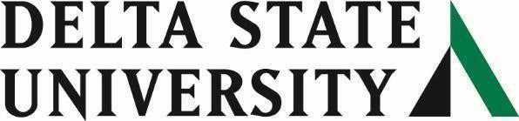
Higher Education Emergency Relief Fund-
Emergency Financial Aid Grants to Students

Monthly Report as of June 23, 2021

Fund Acknowledgment: As part of the Higher Education Emergency Relief Fund II (HEERF II) that was authorized by the Coronavirus Response and Relief Supplemental Appropriations Act of 2021 (CRRSAA) and signed into law on December 27, 2020, Delta State University has received $1,262,219.00 to provide HEERF II emergency grant aid to students. DSU will follow the instructions and guidance provided by the Federal Department of Education to allocate these funds accordingly.

Total Funding: Delta State University received $1,262,219.00 in Higher Education Emergency Relief Fund (HEERFII) – Student Aid.
Funding Disbursed: As of June 23, 2021, $947,475 has been awarded to students.
Eligible Participants: For spring 2021, approximately 2,274 DSU students are eligible. For summer I, approximately 890 DSU students are eligible.
Total Recipients: As of June 23, 2021, 1,345 students have received assistance.
Methodology: Students were encouraged to complete a Free Application for Federal student Aid (FAFSA) to verify eligibility requirements are met under Section 484 in Title IV of the Higher Education Act of 1965, as amended (HEA). The maximum Federal Pell grant for the 2020-2021 academic year is being used as the maximum award threshold per student subject to tiered estimated family contribution levels and cost of attendance maximums by category for the applicable academic term.
Application Instructions, Directions, Guidance: Emergency Aid - Student Affairs (deltastate.edu)
Spring Semester: DSU students were provided instructions and guidance through email and on the DSU website as of March 1st. The deadline to apply was March 15th.

Summer I: DSU students were provided instructions and guidance through email and on the DSU website as of May 27th. The deadline to apply was June 13th.

