

Bylaws
December 28, 2012

Intentionally left blank
About These Bylaws

These Bylaws have been substantially rewritten and should be reviewed in full. Overall changes include:

- Reformatting to correct typos and layout issues,
- Numerous corrections to ensure consistent use of terms,
- Use of Times Roman 12 pitch throughout to improve readability, and
- Reorganization and renumbering of existing Articles into theme based groupings to improve utility. Only one Article was deleted during this process, Article XXII, “Policies and Procedures”, which concerned policies and procedures for the Board of Directors. It was retained in full, but incorporated into the new Article V, “Board of Directors”, as a new Section 9.

In addition, significant changes were incorporated to address organizational, and roles and responsibilities issues the Association will face when operating without a dedicated staff. Changes of this nature are noted with footnotes at the bottom of each page.

Future Revisions

To facilitate issuance of future revisions to these Bylaws as individual pages, the table below is provided to log any such changes.

Revision Number | Page(s)  Affected | Issue Date | Item
1
2
3
4

Intentionally left blank
Table of Contents

GENERAL 1
ARTICLE I. Name, Headquarters, and International Affiliation 1
ARTICLE II. Purpose 1

MEMBERSHIP 1
ARTICLE III. Types and Privileges 1
ARTICLE IV. Dues, Fees, and Assessments 3

ORGANIZATION 3
ARTICLE V. Board of Directors 3
ARTICLE VI. Association Officers 4
ARTICLE VII. Committees 6
ARTICLE VIII. Chapters, Special Interest Groups, and Organizational Relationships 9

OPERATIONS 10
ARTICLE IX. Publications 10
ARTICLE X. Annual Meeting 10
ARTICLE XI. Executive Director 10
ARTICLE XII. Finances 11
ARTICLE XIII. Insurance 11
ARTICLE XIV. Indemnification 11

STANDARDS OF CONDUCT 12
ARTICLE XV. Ethics 12
ARTICLE XVI. Non-Inurement 12
ARTICLE XVII. Conflicts of Interest 12

BOARD SELECTION 13
ARTICLE XVIII. Nominations 13
ARTICLE XIX. Elections 14

GOVERNANCE 14
ARTICLE XX. Parliamentary Authority 14
ARTICLE XXI. Referendum 14
ARTICLE XXII. Bylaws Amendments 14

APPENDICES
Appendix 1. GITA Written Guidance Hierarchy and Rationalization……………………...…………A-1
Appendix 2. GITA Organizational Diagram…………………………………………………….…….A-2

Intentionally left blank
Bylaws of the Geospatial Information & Technology Association
December 28, 2012

GENERAL

ARTICLE I. Name, Headquarters, and International Affiliation

Section 1. The name of this organization shall be Geospatial Information & Technology Association (GITA), referred to in these Bylaws as “the Association.”

Section 2. The Association shall maintain a headquarters for the promotion of Association objectives. The headquarters shall be established at such a place and with such facilities and functions as the Board may direct.

Section 3. The Association is part of a consortium of affiliated international organizations and is known as the North American Affiliate in that context.

ARTICLE II. Purpose

Section 1. GITA is the leading provider of accessible and effective education and training to fulfill the needs of those individuals interested in geospatial information and technology in rapidly changing disciplines.

Section 2. The purpose of the Association is to provide leadership in offering excellent educational and information exchange opportunities in geospatial information and technology and to promote the use and development of geospatial database and graphic technology to meet our members’ evolving needs.

Section 3. Further, the purpose of the Association is to provide the benefits referred to above to utilities; local, state and federal governments and their agencies; other interested organizations; and the general public.

MEMBERSHIP

ARTICLE III. Types and Privileges

Section 1. Classes of Membership

- Individual. Membership is open to all individuals who are interested in learning and teaching geospatial information and technology and who are willing to pay annual dues to the Association.

- Sponsor. Membership is open to all organizations with special knowledge, experience, or interest in the field of geospatial information and technology willing to pay annual sponsor dues to the Association.

- Contributor. Membership is open to all organizations with special knowledge, experience, or interest in the field of geospatial information and technology willing to pay annual contributor dues to the Association.

- Small Business Affiliate. Membership is available to all individuals engaged in providing products or services in the field of geospatial information and technology, providing that the organization for which the individual works employs five (5) or fewer persons in any capacity (fulltime, part time, subcontract, etc.), and who are willing to pay annual small business affiliate dues to the Association.

- User Affiliate. Membership is available to all organizations that are not engaged in the selling for profit of geospatial information and technology products or services and who are willing to pay annual user affiliate dues to the Association.

- Students. Membership is open to all fulltime students who are engaged in studies of geospatial information and technology who are willing to pay annual student member dues to the Association.

Section 2. Individual, sponsor, contributor, small business affiliate, and user affiliate have all rights and privileges of membership, including the right to serve on committees and to vote and hold office.

Section 3. Voting Privileges

- Each Individual member shall have a single (1) vote.

- Each Sponsor shall designate two (2) individuals for membership status who shall each have all voting and other privileges available to an Individual member.

- Each Contributor shall designate one (1) individual for membership status who shall have all voting and other privileges available to an Individual member.

- Each Small Business Affiliate shall designate one (1) individual who shall have all voting and other privileges available to an individual member.

- Each User Affiliate shall designate two (2) individuals for membership status who shall each have all voting and other privileges available to an Individual member.

- Student members shall not have voting privileges.

ARTICLE IV. Dues, Fees, and Assessments

Section 1. Dues and benefits for all categories of membership shall be determined by the Board annually.

Section 2. Nonpayment of dues shall be considered as equivalent to a resignation from the Association.

Section 3. All other fees and assessments shall be determined by the Board.

ORGANIZATION

ARTICLE V. Board of Directors

Section 1. The Association’s Board of Directors (the “Board”) shall consist of a minimum of five (5) individuals, who shall be members of the Association. As described in Article VI, they shall be the five (5) officers of the Association (Executive Committee). As deemed appropriate by the Association’s officers, a maximum of six (6) additional at-large Board members may be added to the Board for the purposes of facilitating operations of the Association. To minimize the opportunity for deadlock votes, at-large members will be added to the Board in blocks of two (2). If the Association has retained services of an Executive Director, the Executive Director shall serve on the Board ex-officio, without vote.

Section 2. Board members shall serve no more than eight (8) consecutive one-year terms.

Section 3. Regular meetings of the Board shall be held at times and places specified by the Board or Executive Committee and may be conducted in person, by teleconference, or by virtual meeting. A quorum at any Board meeting shall consist of a majority of the Board’s membership. Special meetings of the Board may be called by the President or any three members of the Board.

Section 4. Written notice of Board meetings shall be electronically mailed to each Board member at least two (2) weeks in advance of Board meetings. A majority of Board members in attendance shall constitute a quorum.

Section 5. In the case of disability or resignation of a Board member, the Board shall fill the vacancy until the next regularly scheduled Board election. A membership election to fill the position for the remainder of the vacant Board term will be held at the next regularly scheduled Association election.

Section 6. Any officer or Board member may be removed from office before the expiration of his/her term by a three-fourths vote of the Board if evidence is present that the best interests of the Association are not being served.

Section 7. The Board shall be responsible for managing the affairs of the Association and for the promotion of the Association’s mission and purpose. The Board shall have the authority, by majority vote, to take such actions as are necessary for the conduct of the Association’s affairs in accordance with these Bylaws (except as otherwise provided under Colorado law). Votes by proxy shall be allowed provided no one individual controls more than 25% of the available votes.

Section 8. Action taken by a mail, email, fax, telephone or on-line ballot of the Board shall be a valid action of the Board and shall be reported at the next regular meeting of the Board.

Section 9. The Board shall adopt policies and procedures to govern its procedures (Board Policies and Procedures Manual), which shall not be in conflict with these Bylaws. Such rules may be adopted or repealed by a two-thirds vote of the Board.

ARTICLE VI. Association Officers

Section 1. The officers of the Association shall be: the President, the President-Elect, the Immediate Past-President, the Secretary, and the Treasurer, all with vote, and the Executive Director (if employed by the Association) who shall serve ex-officio, without vote. With the exception of the Executive Director, they shall hold office for a one-year term, or until their elected successors take office.

Section 2. The President shall be a member of the Association who has just completed a term as President-Elect. The President shall represent the entire membership and the best interests of the Association, be the official spokesperson for the Association (but may assign this authority), serve as the presiding officer of the Association, serve as Chairman of the Executive Committee, serve as Chairman of the Board of Directors, serve as Chairman of the Compensation Committee, support and defend policies and programs adopted by the Board of Directors and membership, be an ex-officio member of all committees of the Association except as otherwise provided, have additional duties that are not inconsistent with the Bylaws as may be assigned by the Board of Directors, and appoint chairs of all committees with ratification of the Board of Directors. In the event the President is absent or unable to act, the President-Elect shall perform the duties and exercise the powers of the President.

Section 3. The President-Elect shall be a member of the Association who is elected by the membership. The President-Elect shall take office on January 1 of each year. The President-Elect automatically succeeds to the office of President. If the office of President becomes vacant, the President-Elect shall serve as President for the unexpired term and shall serve as President for the term to which he/she was elected.

Section 4. In the event that the President-Elect shall not be able to serve, a President-Elect shall be nominated by the Governance Committee and a special election shall be held at the discretion of the Board. The new President-Elect shall take office immediately.

Section 5. In the event that both the President and the President-Elect shall be unable to serve, the Governance Committee shall nominate a new President and President-Elect and a special election shall be held at the discretion of the Board. The new President and President-Elect shall take office immediately.

Section 6. The Immediate Past-President shall serve on the Board and the Executive Committee for the year immediately following his/her presidency, and shall have such duties as the Board or the President may designate.

Section 7. In the event the Board votes to terminate all employees of the Association, all then serving Board members will have their terms of service extended by one year in order to provide continuity of operations for the Association. All members of the Board will remain in their previously assigned roles with the exception of the then current President who will become the Immediate Past-President at the end of the normal period of service as President. Commencing on the date that the then President becomes the Immediate Past-President, the incoming President and Immediate Past-President shall each serve a term of two years. In order to provide for the services of a President-Elect during the first year of the incoming President’s two-year service, the Governance Committee shall nominate for Board consideration a Past-President of the Association who will serve in that capacity for a period of one year. Elections to provide for a President-Elect, Secretary, Treasurer and any Board members-at-large who were extended, will be held in accordance with a schedule that provides for replacement at the end of the second year of service (see “Board Selections”). Subsequent elections will return all Board members to a one-year period of service. In the event this Section is in conflict with any other language in these Bylaws, this Section shall prevail.

Section 8. The Secretary shall be a member of the Association and shall be elected by the membership. The Secretary shall be the recording officer of the association and the custodian of its records. The Secretary shall be Chairman of the Association’s Governance Committee. The Secretary shall perform all such other functions and duties as appropriate and customary for the office of Secretary, and as the Board of Directors shall prescribe.

Section 9. The Treasurer shall be a member of the Association and shall be elected by the membership. The Treasurer shall deliver an audited report for each fiscal year to the Board. The Treasurer shall be Chairman of the Association’s Finance Committee. The Treasurer shall perform all such other functions and duties as appropriate and customary for the office of Treasurer, and as the Board of Directors shall prescribe.

Section 10. There shall be a description of responsibilities for each officer maintained by the Secretary of the Association, which shall be reviewed annually by the Board, and revised as required.

ARTICLE VII. Committees

Section 1. There shall be standing and ad hoc committees to serve the purposes of the Association as prescribed by these Bylaws and as determined by the Board.

Section 2. Standing committees. The function and structure of standing committees shall be governed by the following:

- Standing committees perform continuing tasks of the Association.

- Standing committees shall report at least annually to the Board and more frequently if required by the Board.

- Standing committees may be added, modified, or disbanded at the direction of the Board without a change in the Bylaws unless otherwise provided in the Bylaws.

- Standing committees shall adhere to Board of Director approved policies and procedures (Committee Policies and Procedures Manual).

Section 3. The following standing committees are Board member led (critical operations) and exist to fulfill the purposes of the Association:

- Executive Committee. Retains all the powers of, and acts for the Association, between meetings of the Board. It shall report all its actions at the next regular meeting of the Board. The committee shall be composed of the President, President-Elect, Immediate Past-President, Secretary, Treasurer, and Executive Director (if employed by the Association). The Executive Director will not have a vote. The Executive Committee is responsible for developing and managing the near term plans and long range vision of the Association.

- Compensation Committee. As needed, conducts annual review of the Executive Director’s performance and associated compensation. Retains record of these reviews for a minimum of seven (7) years. Recommends to the Board of Directors the compensation level for the Executive Director and annual employee benefits package for all other staff. Maintains watch on total compensation package provided to all employees of the Association. Maintains written policies and procedures related to the same, and negotiates and drafts contracts as needed. Executes same responsibilities for any contract services needed by the Association. There will be a minimum of three members on the committee: the President (Chairman), Past-President, and Treasurer of the Association. As deemed appropriate by the Board, additional members of the Board, in blocks of two (2), may be added as voting members to the committee.

- Finance Committee. Formulates and recommends an annual budget to the Board. It reviews and presents an annual audit of the Association, and ensures all IRS and other required financial filings are completed in timely fashion. There will be a minimum of three members on the committee: the Treasurer (Chairman), President, and President-Elect. As deemed appropriate by the Board, additional members of the Board, in blocks of two (2), may be added as voting members to the committee.

- Governance Committee. Conducts ongoing review of Association governance and operating policies and procedures. In its purview shall be: Association Bylaws, the Board of Directors Policies and Procedures Manual, Committee Policies and Procedures Manual, Chapter Policies and Procedures Manual, Operations Policies and Procedures Manual, Association Code of Ethics, and all such other similar documents related to the structure, management, operation and governance the Association. As circumstances warrant, it shall recommend changes to the Association’s manuals to the Board of Directors. Committee shall also ensure the timely filing of all documents required by Federal and state officials to maintain nonprofit status. In addition, the committee is responsible for the nomination and election of members of the Board of Directors. There will be a minimum of three members on the committee: the Secretary (Chairman), President, and President-Elect. As deemed appropriate by the Board, additional members of the Board, in blocks of two (2), may be added as voting members to the committee.

Section 4. Each of the following standing committees (mission operations) will be preferably led by an Association member-at-large who is not a member of the Board of Directors. The President of the Association will nominate the Chairman of each committee, and a majority vote of the Board of Directors will confirm the appointment. The Chairman of each committee and all others wishing to serve on these committees will conduct business as delineated in the Committee Policies and Procedures Manual, and any Appendix therein specific to the committee. The Board shall assign a liaison to each of these committees for the purposes of facilitating the flow of information between the Board and the committee. As needed, the Board will consider providing administrative and technical support to these Committees.

- Awards Committee. Manages all functions related to nomination, selection and presentation of the Association’s awards.

- Education Committee. Ensures that the continuing education needs of the membership are met by interfacing with the Association’s committees and membership.

- Events Committee. Manages all functions related to the scheduling, managing, and production of events where GITA is a formal participant or sponsor. Work groups may be formed as needed to develop event specific content or venues.

- Research Committee. Works to facilitate and promote research efforts that benefit members of the organization through engagement with the greater utility, geospatial, education, government and related communities.

Section 5. Each of the following standing committees (core operations) will be preferably led by an Association member-at-large who is not a member of the Board of Directors. The Chairman of each will be nominated by the President of the Association and selected by a majority vote of the Board of Directors. The Chairman and all others wishing to serve on these committees will conduct business as delineated in the Committee Policies and Procedures Manual, and any Appendix therein specific to the committee. The Board shall assign a liaison to each of these committees for the purposes of facilitating the flow of information between the Board and the committee. The Board will provide administrative and technical support to these Committees as needed.

- Communications Committee. Coordinates production and distribution of the Association’s publications. It manages policies concerning all publications, reviews and recommends new documents to be published, and oversees existing publications including journals and newsletters. Develops new releases and web site content as needed.

- IT Infrastructure Committee. Responsible for oversight and management of all Association IT infrastructure. At a minimum, this includes the functionality of the Association website(s), data bases, administrative files, phone systems, email servers and all other technical systems required by the Association.

- Membership Services Committee. Manages all aspects of the Association membership function including enrollment, membership drives, structure, and chapter engagement. Reviews and recommends membership criteria and policy. It shall also serve as the review committee for membership privileges.

Section 6. Ad hoc committees. The function and structure of ad hoc committees shall be governed by the following:

  - Creation and dissolution of ad hoc committees must be approved by the Board.

  - Ad hoc committees perform specific tasks.

  - Ad hoc committees shall report on a timely basis to the Board.

  - Ad hoc committees shall cease to exist when a final report is submitted, or at such other time as designated by the Board.

ARTICLE VIII. Chapters, Special Interest Groups, and Organizational Relationships

Section 1. The Association may encourage and recognize the establishment of regional, state, and local chapters having missions and purposes consistent with those of the Association.

Section 2. The Association may encourage and recognize special interest groups within the Association having missions and purposes consistent with those of the Association.

Section 3. The Association may encourage and recognize organizational relationships with other associations having missions and purposes consistent with those of the Association.

Section 4. The structure, operations, purposes, mutual goals, and benefits of the organizational relationships are to be specified in the Association’s Operations Policies and Procedures Manual and are subject to Board of Directors approval. Modifications made to such policies and procedures from time to time are subject to Board approval.

OPERATIONS

ARTICLE IX. Publications

Section 1. The Association’s newsletter is the official communication to the membership.

Section 2. Any notice in the newsletter shall be considered full notice to all members of the Association for any purpose.

ARTICLE X. Annual Meeting

There shall be an Annual Business Meeting of the Association at a time and place to be determined by the Board.

ARTICLE XI. Executive Director

Section 1. As deemed appropriate by the Board of Directors, the Association shall retain an Executive Director.

Section 2. The Executive Director shall be appointed by the Board. The Executive Director shall direct the day-to-day activities of the Association according to the Association’s Operations Policies and Procedures Manual, which will be reviewed and approved by the Board on an annual basis. The Executive Director shall be responsible for the thoroughness and on-going maintenance of this manual.

Section 3. The Executive Director shall have authority to sign checks and drafts as agent of the Association for the disbursement of funds for duly authorized purposes of the Association. Limits and procedures for such disbursements shall be documented in the Association’s Operations Policies and Procedures Manual.

Section 4. The Executive Director shall serve ex-officio, without vote, on all committees of the Association.

Section 5. The Executive Director shall report to the Board annually on the operations of the Association.

ARTICLE XII. Finances

Section 1. The fiscal year of the Association shall be set by the Board.

Section 2. All officers and agents of the Association responsible for the receipt, custody, and disbursement of funds may be required to give bond for the faithful discharge of their duties in such sums and with such sureties as the Board may determine.

Section 3. All checks, drafts, and other orders for the payment of money, notes, or other evidences of indebtedness issues in the name of the Association shall be signed by such officers or agents of the Association and in such a manner as shall be determined by the Board and documented in the Association’s Operations Policies and Procedures Manual.

Section 4. An audit shall be performed by a Certified Public Accountant, as determined by the Board. Copies of this audit shall be distributed to the Board.

ARTICLE XIII. Insurance

Section 1. By action of the Board of Directors, notwithstanding any interest of the directors in the action, the Association may purchase and maintain insurance, in such amounts as the Board of Directors deem appropriate, on behalf of any person who is or was a director, officer, or employee of the Association against any liability asserted against and/or incurred by that person in any such capacity, or arising out of that person’s status as such, whether or not the Association would have the power to indemnify that person against such liability or expense under the provisions of Article XIV.

Section 2. Notwithstanding the foregoing provisions of this Article, no insurance premiums shall be paid by the Association on behalf of any director, officer, or employee who is a “disqualified person” to the extent that such payment would constitute an act of self-dealing under section 4941 of the Internal Revenue Code.

ARTICLE XIV. Indemnification

The Association shall indemnify any person and his or her estate and personal representative against all liability and expense incurred by reason of the person being or having been a director, officer, or employee of the Association to the full extent and in any manner that such person may be indemnified under the Colorado Nonprofit Incorporation Act as in effect at any time. The Association shall also indemnify any person who is serving or has served the Association as director, officer, employee, or agent, and that person’s estate and personal representative, to the extent and in the manner provided in any bylaw, resolution of the directors, contract, or otherwise, so long as such provision is legally permissible.

STANDARDS OF CONDUCT

ARTICLE XV. Ethics

Members of the Association shall be bound by a Code of Ethics as adopted by the Board.

ARTICLE XVI. Non-Inurement

The Association is not organized for profit, and no part of an income, revenue, or grant of or to the Association shall inure to the benefit of any member, officer or other private person, except as reasonable compensation for services rendered in furtherance of one or more of its purposes, or for necessary expenses actually incurred.

ARTICLE XVII. Conflicts of Interest

Section 1. The officers and directors of the Association have a fiduciary relationship to the Association. This relationship requires that, in performance of their duties, they shall act in good faith, with undivided loyalty to the Association, and with the high degree of diligence, care, and skill that reasonably prudent persons would exercise in the conduct of their own affairs. This relationship further requires that the officers and directors of the Association may not take advantage of their position, or the knowledge gained from their position, for private gain or other personal advantage, either for themselves, their families, or anyone else with whom they have a direct or indirect personal or financial interest, to the detriment of the Association. Specifically, this fiduciary relationship requires the avoidance of conflicts of interest and the affirmative duty to reveal to the Board conflicts of interest and apparent conflicts of interest that may exist through the disclosure of interests and activities such as the ownership, direct or indirect, of a financial or other interest in organizations supplying goods or services to the Association, or in organizations that provide services competitive with the Association; the performance of services to other organizations that do business with or are competitive with the Association; the receipt or acceptance of benefits from any organization doing, or seeking to do, business with the Association or with a competitor of the Association; or participation in or taking advantage of any business opportunity or activity that may be competitive with the Association.

Section 2. No contract or transaction entered into by the Association shall be rendered invalid by the fact that an officer or director of the Association is personally interested in it or may have interests that are or might be adverse to the interests of the Association if, at the meeting of the Association Board making, authorizing or confirming such contract or transaction the interested officer or director discloses (or causes to be disclosed) his or her interest in such contract or transaction, refrains from affirmatively asserting his or her influence in speaking or voting for the adoption of such contract or transaction, and such contract or transaction is adopted or ratified by a majority of all of the directors who are not so interested after first determining in good faith that (1) such contract or transaction is in the best interests of the Association notwithstanding the adverse or potentially adverse interests of the interested officer or director and (2) that such contract or transaction was not entered into solely because of the position of such interested officer or director with the Association.

BOARD SELECTION

ARTICLE XVIII. Nominations

Section 1. The Governance Committee shall prepare a slate of nominees for vacant Board positions.

Section 2. The Governance Committee shall nominate a candidate for each position to be voted upon at the annual election and shall notify the membership, in writing, of its nominees by no later than October 1st. No member of the Governance Committee is eligible to be nominated for any elected position.

Section 3. The Governance Committee shall nominate a candidate for each of the vacant at-large positions on the Board. At-large Board positions will be appointed annually by the President for a term of one (1) year, after review by the Executive Committee and confirmation by the Board. Appointments of at-large members and notification of the membership will correspond to the schedule observed for elected positions.

Section 4. The Governance Committee shall verify the eligibility of nominees as specified in the Association’s Board of Directors Policies and Procedures Manual and shall determine that all nominees meet all requirements to serve.

ARTICLE XIX. Elections

Section 1. Printed ballots shall be mailed to members by no later than October 1st.

Section 2. Ballots are valid if postmarked by October 31st and received by the close of business on November 15th. A count shall be made by the Governance Committee of the votes and a report made to the Board and the membership. Tie votes shall be resolved by a vote of the Board. This section shall apply to all elections unless otherwise specified in these Bylaws.

Section 3. A complete file of all ballots, tallies, and documents of Governance Committee actions shall be maintained in the Association’s files for a period of at least one (1) year.

Section 4. Announcement of election results shall be made by the President by no later than December 1st by electronic mail and in the newsletter of the Association.

GOVERNANCE

ARTICLE XX. Parliamentary Authority

Robert’s Rules of Order shall serve as the parliamentary reference to govern the proceedings for any or all matters of the Association, or its chapters or other subgroups, unless provided otherwise in the Association’s documents or the law.

ARTICLE XXI. Referendum

Except as otherwise required by law, upon petition of twenty (20) percent of the voting members in good standing, a request for a mail vote of the members of the Association upon any matter may be addressed to the Board. If the matter is not inconsistent with these Bylaws, the Board shall present it to the membership for a mail ballot. The ballot shall contain a statement of the arguments for and against the new provisions (if any). The issue will be decided by the majority of those voting.

ARTICLE XXII. Bylaws Amendments

Section 1. The Bylaws of the Association may be amended, altered, or repealed by a majority vote of the Board of Directors.

Section 2. Amendments of the Association’s Bylaws may be proposed by the Board or by petition signed by twenty (20) percent or more of the active members of the Association. Votes on proposed amendments postmarked within thirty (30) days of the date mailed will be counted under the supervision of the Governance Committee. If passed by majority vote, the amendment shall go into effect immediately.

Section 3. Amendments to the Association’s Articles of Incorporation will be made in accordance with the Colorado Nonprofit Corporation Act, as the same is in effect from time to time, and may include voting by mail by the Association’s members entitled to vote for amendments to the Articles of Incorporation, as provided in said Colorado Nonprofit Corporation Act.

Section 4. Any amendments to the Association’s Bylaws or Articles of Incorporation that affect the voting rights of its members, as well as the quorum requirements applicable to voting members, must be approved by those voting members affected by the proposed change. In such cases, an affirmative response by a majority of the applicable quorum shall constitute approval.

Intentionally left blank

APPENDICES

Appendix 1. GITA Written Guidance Hierarchy and Rationalization.

The diagram for GITA’s written guidance hierarchy and rationalization as provided for in these Bylaws can be found below.

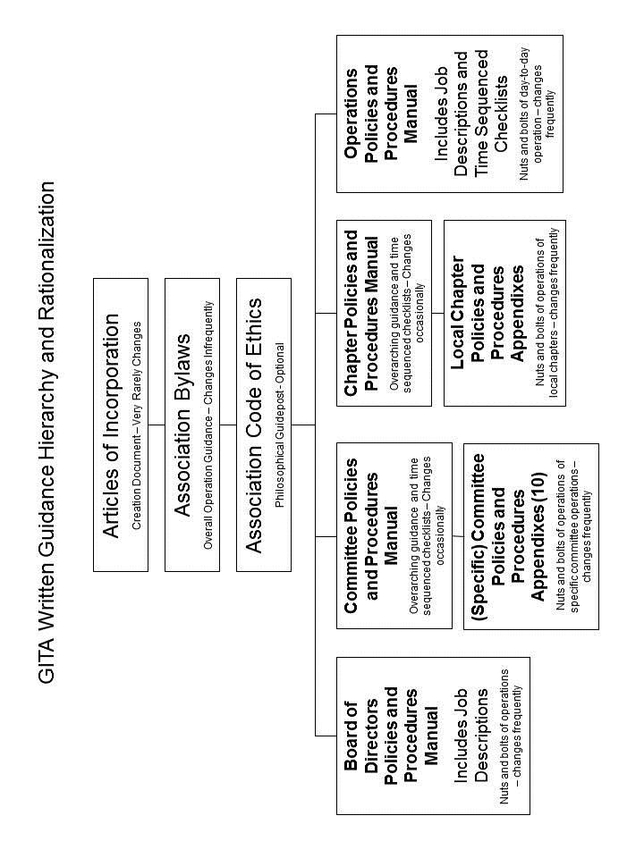

Appendix 2. GITA Organizational Diagram.

The diagram for GITA organizational structure as provided for in these Bylaws can be found below.

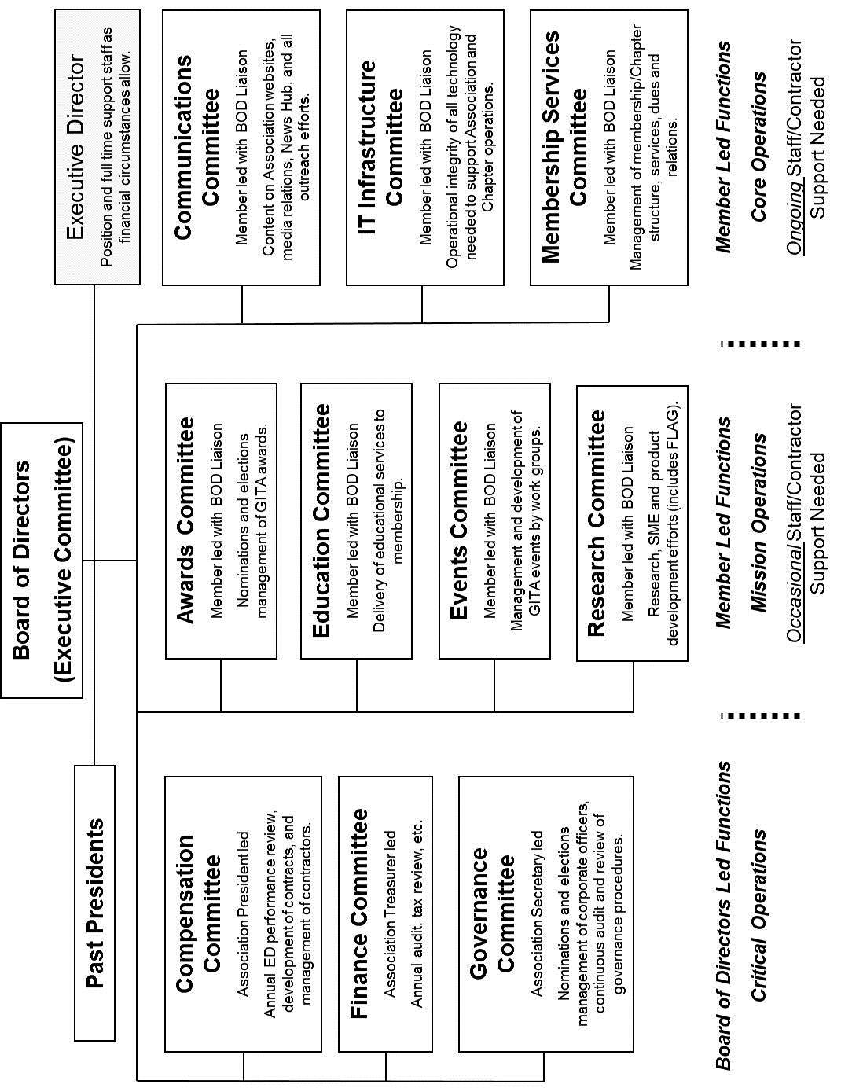

Changed from “Headquarters” to “headquarters”
Idem
Previously: twelve (12)
Added: “as described in Article VI.”
Typo: “There” changed to “They”
Previously: “and a minimum of six (6) additional Board members-at-large.” Added: “may be added to the Board for the purposes of facilitating operations of the Association. To minimize the opportunity for deadlock votes, at-large members will be added to the Board in blocks of two (2).”
Added: “If the Association has retained services of an Executive Director”
Added: “and may be conducted in person, by teleconference, or by virtual meeting”
Added: “electronically”
Added: Ability to conduct proxy votes under the “New Zealand” approach
Added: “(Board Policies and Procedures Manual)”
Previously: Wording was ARTICLE XXII. Policies and Procedures
Added: “if employed by the Association”
Replaced: “and” with “or”
Added: “serve as Chairman of the Compensation Committee” in support of new Committee, as defined in Article VII
Previously: “Nominations”
Idem
Entirely new Section to allow for transition of the Association leadership following lay off of all staff.
Previously: “at the offices”
Added: “(Committee Policies and Procedures Manual).
Deleted: “,with the exception of the Executive Committee, are appointed by the Board”.
Added: “are Board member led (critical operations) ”
Added: “(if employed by the Association)”
Added to replace: “The Strategic Planning Committee plans and coordinates the Association’s Long Range Strategic Plan and Yearly Action Plan.”
Entirely new paragraph supporting August 27-28, 2010 and July 20, 2011decisions by Board of Directors to create a Compensation Committee in order to bring Association practices into alignment with national “Best Practices” for nonprofits. Although core membership of the Compensation and Finance Committees are functionally the same, each performs an entirely different task and may have very different composition depending on decisions by the Board.
Added: “and ensures all IRS and other required financial filings are completed in timely fashion”
Previously: “There shall be four members: the Treasurer (Chairman), President, President-Elect, and one other Board member elected by the Board members who are not officers.”
Deleted after: “and one other Board member elected by the Board members who are not officers.”
Added: “As deemed appropriate by the Board, additional members of the Board, in blocks of two (2), may be added to the committee.”
Responsibility assigned from a previously undescribed “Ethics Committee”
Responsibility assigned from the “Committee on Structure”. Deletion as follows: “a. Committee on Structure. The President-Elect serves as Chairman, and members are the President, Past-President, and Treasurer of the Association. The committee recommends to the Board: (1) the annual goals and objectives for each standing and ad hoc committee, (2) the chairman and member of each standing and ad hoc committee, and (3) the formation or dissolution of ad hoc committees.
Responsibility assigned from the “Nominations Committee” and an “Elections Committee”. Previously: “The Nominations Committee prepares a list of qualified candidates for the Association’s elections. The members of this committee shall be: the Immediate Past-President as Chairman, the current President, and the President-Elect.” and “The Election Committee shall supervise all elections and certify the outcome of all elections.”
Entirely new paragraph supporting August 27-28, 2010 and July 20, 2011decisions by Board of Directors to create a Governance Committee in order to bring Association practices into alignment with national “Best Practices” for nonprofits.
Entirely new paragraph supporting the need for vibrant committees that are contributing to the GITA mission
Entirely new sentence acknowledging committee previously not described in Association Bylaws
Previously “conference committee or with other appropriate committees”
New language intended to absorb following deletions: “The Annual Conference Committee plans and coordinates the annual conference”; “The ExecuNet Committee plans and coordinates the Annual ExecuNet Forum.”; and “The Oil & Gas Conference Committee plans and coordinates the Annual Oil & Gas Conference.”
Entirely new paragraph supporting the need for vibrant committees that are contributing to the GITA mission
Previously: “Public Relations”
Deleted: “all of”. Added: “Coordinates production and distribution of”
Replaced: “recommends”
Added: Develops new releases as needed.
Entirely new paragraph acknowledging the need for organized oversight of these systems.
Added: “Services”
Entire sentence is new.
Changed “a” to “the”
Added: “Operations”
Added: “As deemed appropriate by the Board of Directors”
Deleted: “policies and procedures of the Board of Directors.” Added: “to the Association’s Operations Policies and Procedures Manual, which will be reviewed and approved by the Board on an annual basis. The Executive Director shall be responsible for the thoroughness and on-going maintenance of this manual.”
Added: “Operations”
Deleted: “’s Headquarters”
Added: “Operations”
Deleted: “the Association’s”. Replaced with “a”
Changed “XIX” to XIV” due to renumbering
Changed “Corporation” to “Association”
Deleted after “Association”, “which shall be controlling in all decisions of the Ethics Committee.” since rules should apply equally to all, not just an “Ethics Committee”. Changed “Association” to “Board”.
Changed “Nominations” to “Governance”
Changed: “Nominations” to “Governance”
Deleted: "not less than sixty (60) days before the date on which Board terms become effective.” Added: “by no later than October 1st.”
Changed: “Nominations” to “Governance”
Idem
Deleted: “At-large Board members may serve up to three (3) consecutive terms.” In order to make working consistent with intent in Article V, Section 2.
Idem
Deleted: “the day specified in Section 1.” Added: “October 31st and received by the close of business on November 15th”
Changed: “Election” to “Governance”
Idem
Changed: “Headquarters office” to “Association files”
Deleted: “not less than thirty (30) days before the date on which Board terms become effective”. Added: “by no later than December 1st”.
Added: “electronic”
Deleted: “official”
Changed: “Election” to “Governance”

