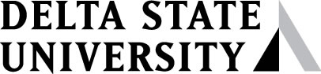
Employee Authorization Form
Direct Deposit of Employee Reimbursements
Employee Name
Employee DSU ID Number
This is an authorization to (please check one):
Establish New Account ☐ Change Financial Institution ☐
Please contact your financial institution if you need assistance with the following information. Note that Direct Deposit payments can only be applied to accounts at domestic (U.S.) financial institutions.

Bank Name
Bank City, State, Zip
Type of Account - Please Check One:
☐ Checking Account (Attach a void check OR a letter from your financial
☐ Savings Account institution to verify your account and routing numbers)
Routing Number
Account Number
I hereby authorize: (1) Delta State University to deposit my funds via Direct Deposit,
(2) My financial institution to credit my account, and
(3) Delta State University to initiate and my financial institution to make
adjustments to my account for any incorrect credits/payments which may occur.

Signature Date

A payment notification will be delivered to your Delta State email address. A new authorization form must be completed if there is any change in your banking information.

