 | Delta State University  Human Resource Management  Kent Wyatt Hall 247  Cleveland, MS 38733  Phone: (662) 846-4035 • Fax: (662) 846-4025  “Developing Partnerships Within the University”
PeopleAdmin
User Guide
PeopleAdmin will establish and maintain an automated internet based system for processing requisitions and accepting applications for employment.

Create Job Posting:
Access the PeopleAdmin site by going to https://deltastate.peopleadmin.com/hr/
(Sample screenshot of the form below)

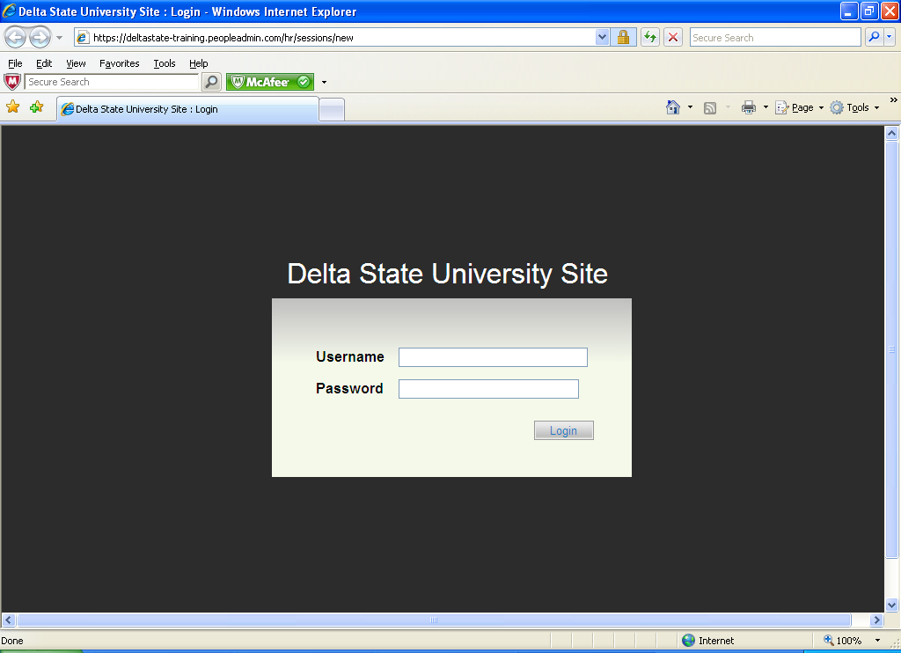
Type in your Username and your Current Delta State Log in Password.

You will now be logged on to our Online Recruitment System.
(Sample screenshot of the form on next page)

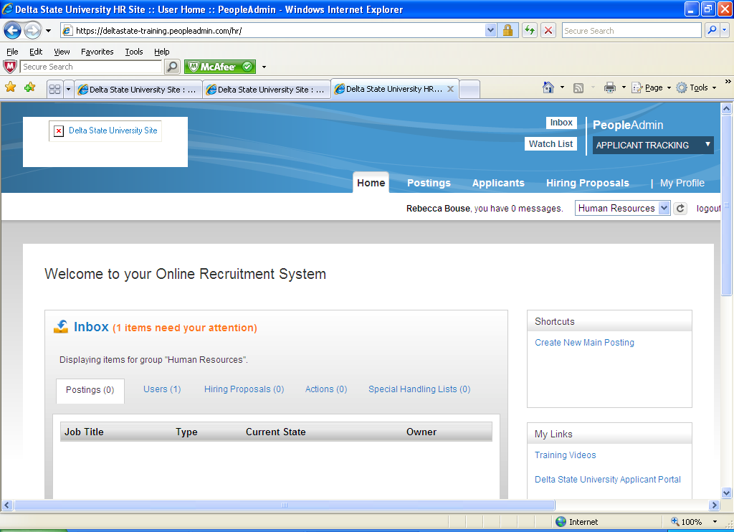

To create of new job posting: Click on Postings on middle/top of screen. Once in site, click Orange Create New Posting button on left side of screen. (Sample screenshot of the form below)

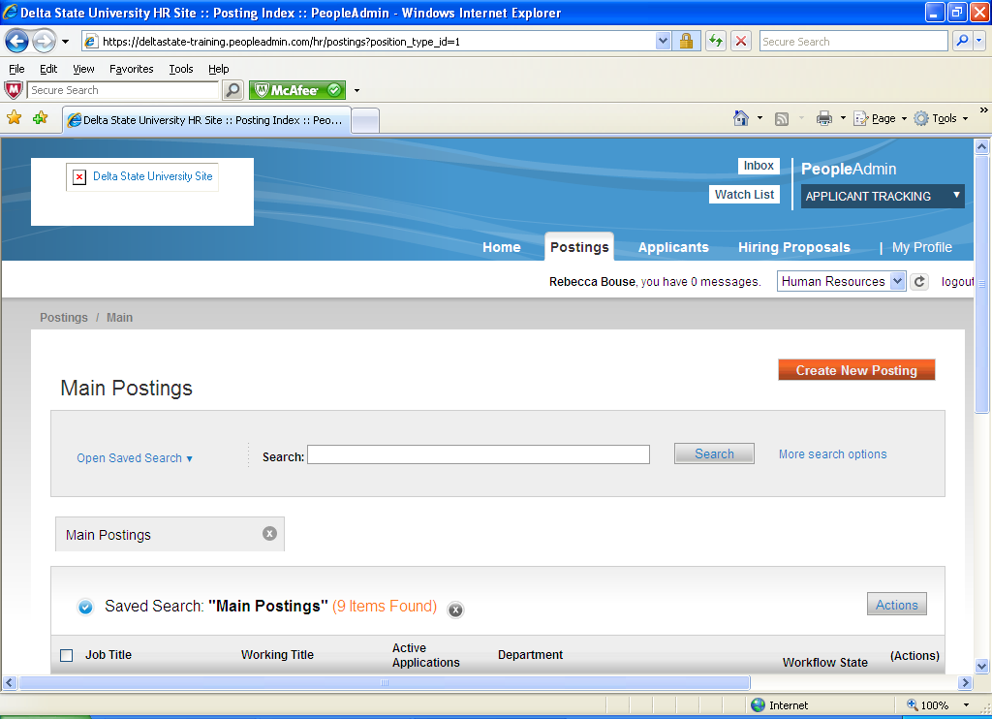

You need to decide how you would like to create your new posting. You will pick from the following:
- Create from Posting Type
- Create from Title
- Create from Posting

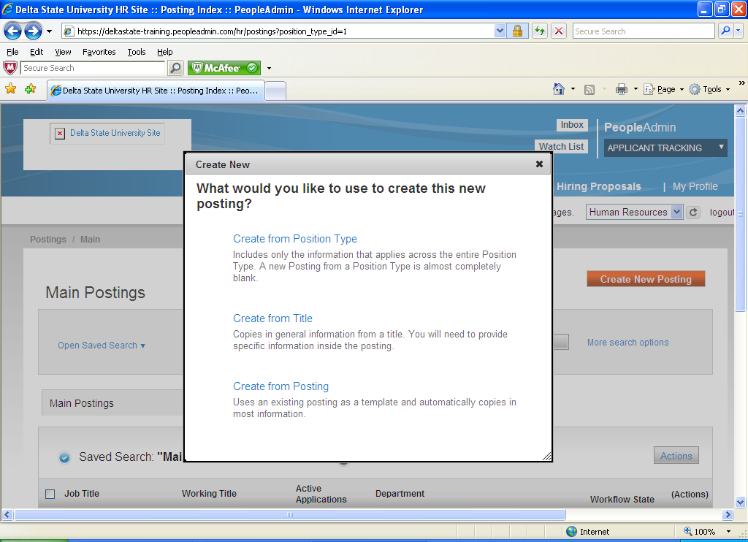
Because the system is new you will be posting from the Create from Position Type. The next time you have to post that same position, it will be in the system under Create from Posting or Create from Title.
You will now type in Job Title. Your Organizational Division and Department will already be filled in.
Click on Orange Create New Posting button.
You are now at the Posting Details page.
To create a Posting, first complete the information on this screen, then click the Next button or select the page in the left hand navigation menu. Proceed through all sections completing all necessary information. To submit the Posting to Human Resources, you must go to the Posting Summary Page by clicking on the Next button until you reach the Posting Summary Page or select Posting Summary Page from the left navigation menu. Once a summary page appears, hover your mouse over the orange Action button for a list of possible approval step options.
(Sample screenshot on next page)
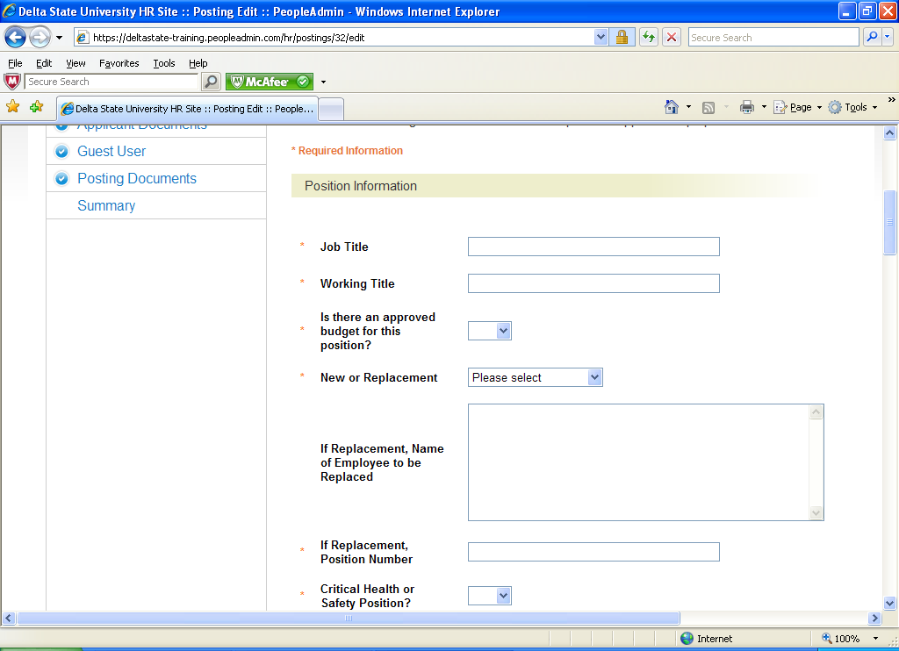
Fill in all the position information. This can be saved at anytime as a draft to work on later.
When you go to the next page you have the option to select Search Committee Members. You will enter First Name, Last Name and Email Address. If they are not located in the system you can request a new search committee member. (Sample screenshot below)
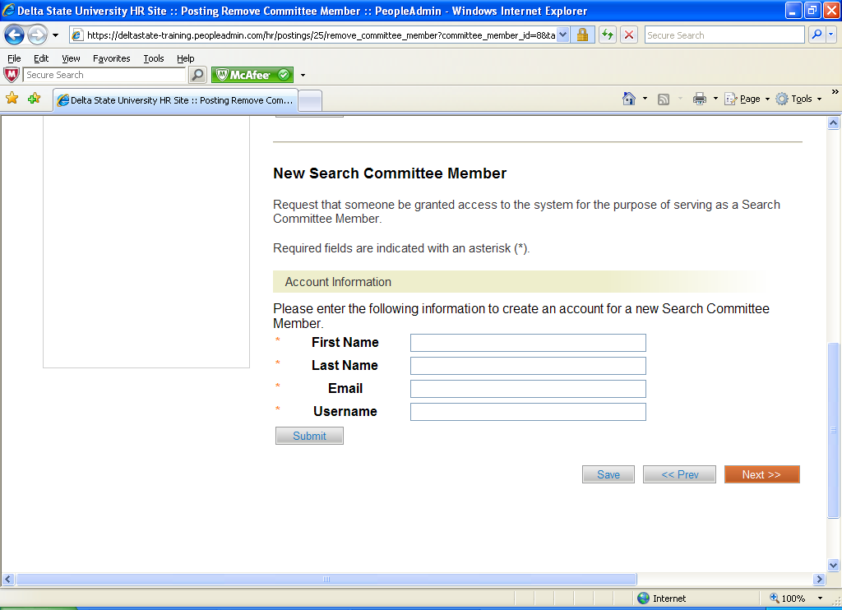
Click on the Next button.

You are now at the Rank Criteria section: You may select or add questions for candidates to answer in the application process. (Sample screenshot below)

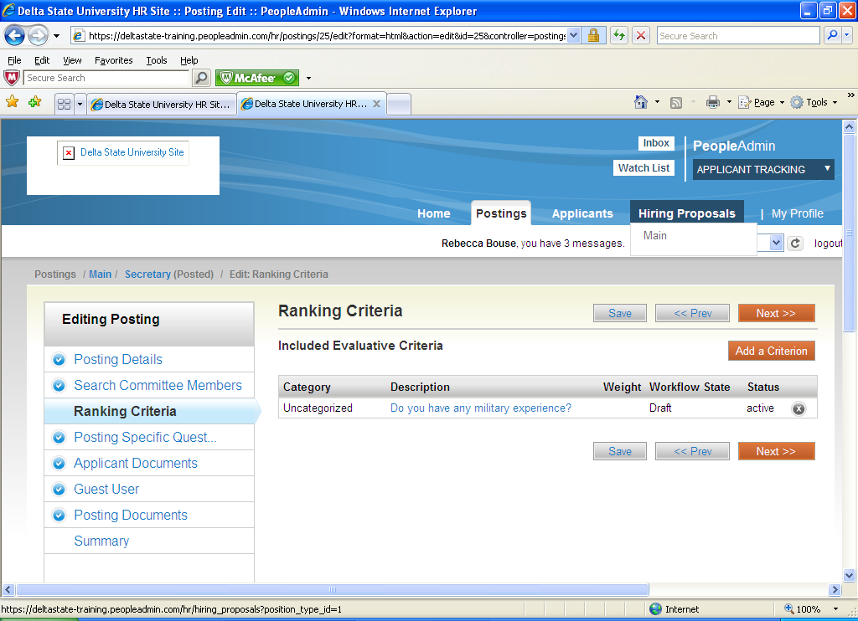

Click on the Next button.

Posting Specific Questions:

- To add a New Posting Questions: Click on the button labeled "Add a Question".
- You can add an existing question.
- You can Assign Points or Disqualifying Responses: Click on the question that has been added and a dropdown menu will appear where points and disqualifying responses can be associated to the posting question.
- Posting Question Options: Once questions have been added to the posting, you will see a column of checkboxes to the left of each question; checking these boxes will make a question required.

(Sample screenshot on next page)

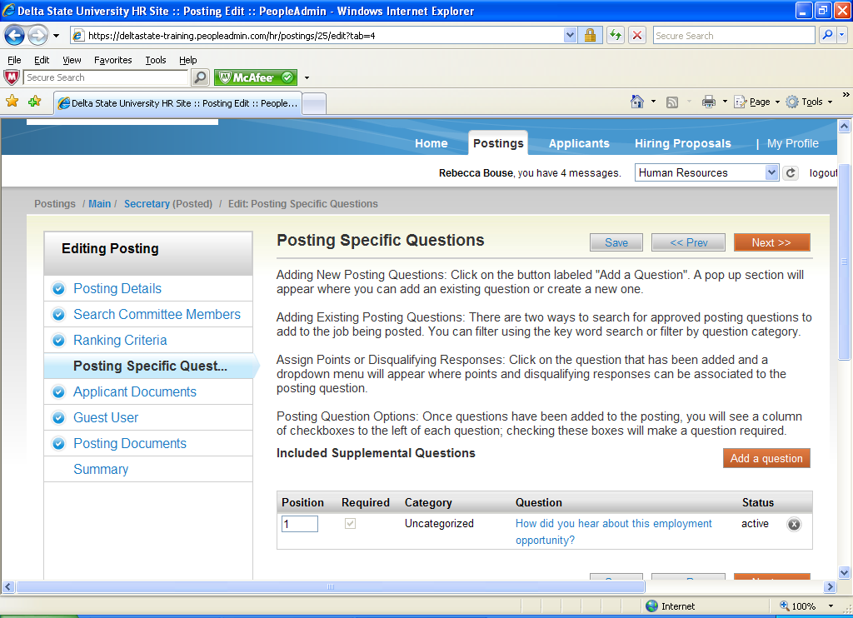

Click on the Next button.

Applicant Documents:
Applicant documents can be included in the application process by selecting Included to make the documents optional and Required and Included to make the document(s) mandatory to complete the application process. (Sample screenshot below)
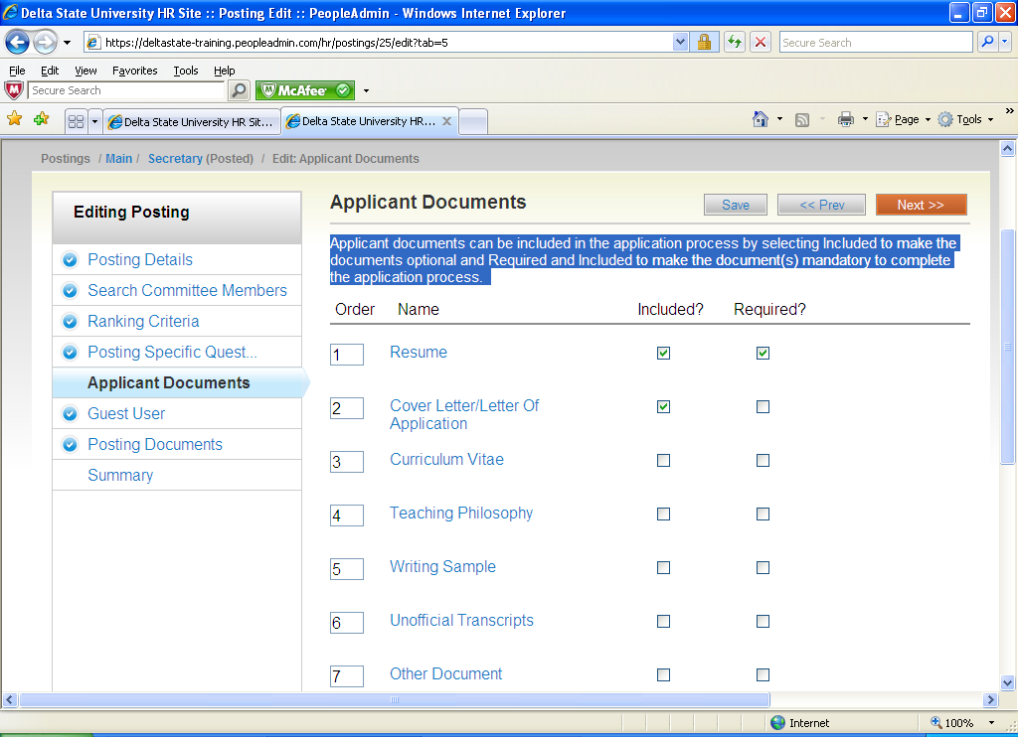
Click on the Next button.
If you need a Guest User, create an account. Guest Users will still need to contact Human Resources receive the Guest User Password.
Posting Documents: To add a document to the posting, hover over the blue Action text link to the right of the document name.
Below is a screen shot of Documents that can be added:
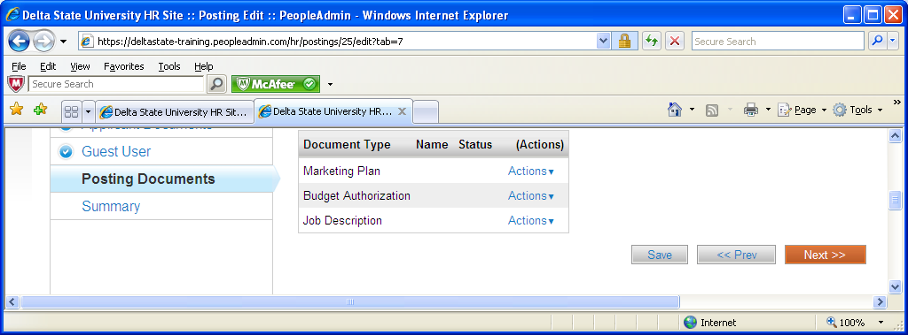
Click on the Next button. Your posting is completed. Please review the details of the posting carefully before continuing. It might be helpful to click on the See how Posting looks to Applicant button. This is what the applicant will see when searching for positions.

Now you will click on the Orange Take Action on Posting button. (Sample screenshot below)

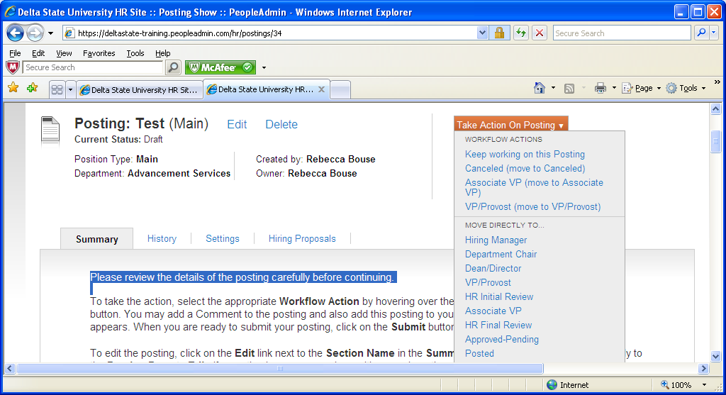
You will move posting to the person who would have signed your Position Requisition next. It will go along the chain of approvers until it reaches Human Resources. Human Resources will approve and post to website.

The Hiring Department will now be setup to receive applications.

Reviewing Applications:

Click on your posting and move cursor to Applicants. Click on the Applicants box. You now will be able to view all the applicants that have applied by clicking on their names.
(Sample screenshot below)

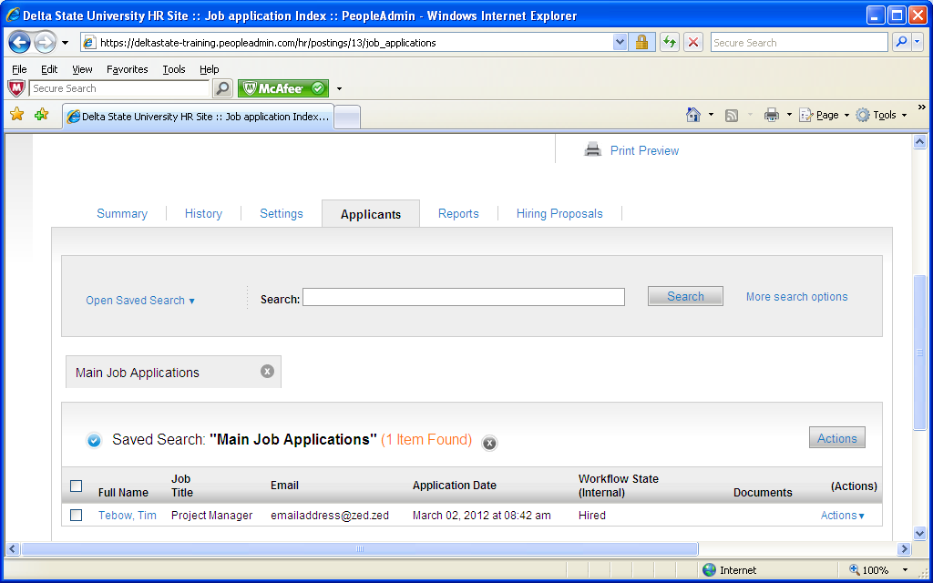

To get a list of all applicants click on the box right next to Full Name or click on the box next to the names you want on the list. Go to the Actions button and click on Export Results. (Sample below)

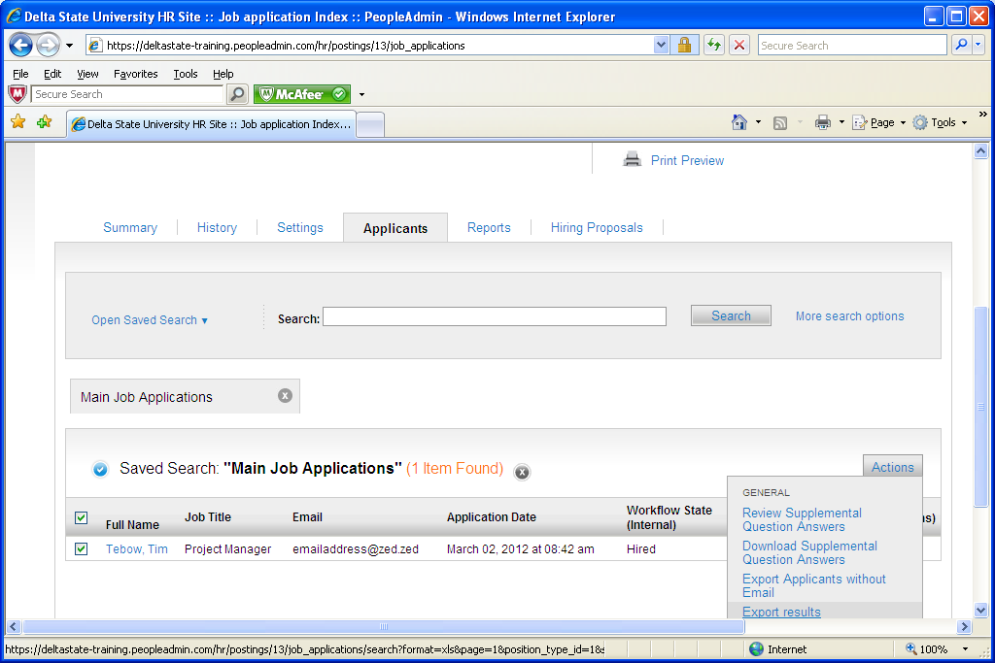
When you have decided on the next action for a candidate(s), click on the Orange Take Action on Job Application button. (Sample screenshot below)

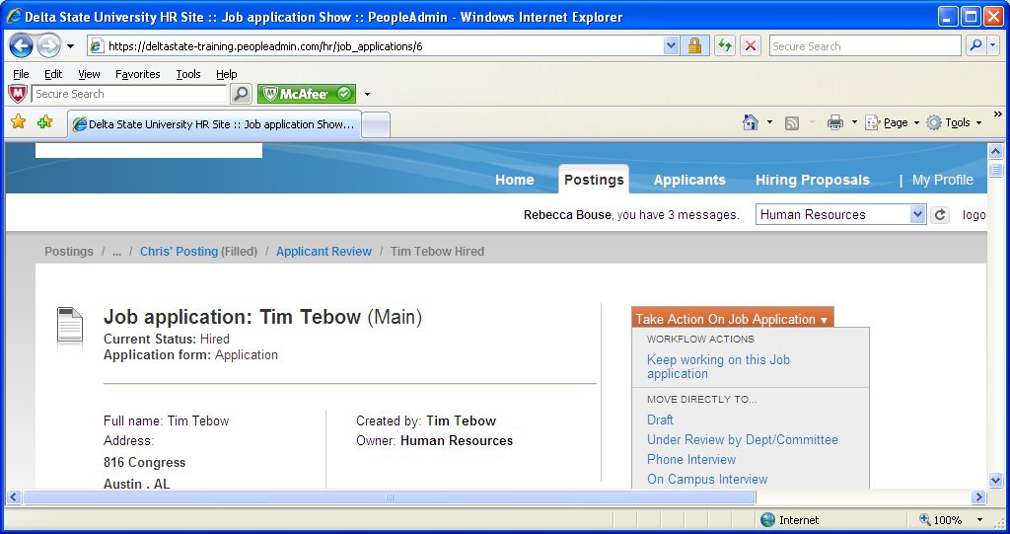

Hiring Proposal:

You will select Recommended for Hire. This will bring up the Start Hiring Proposal.
(Sample screenshot below)

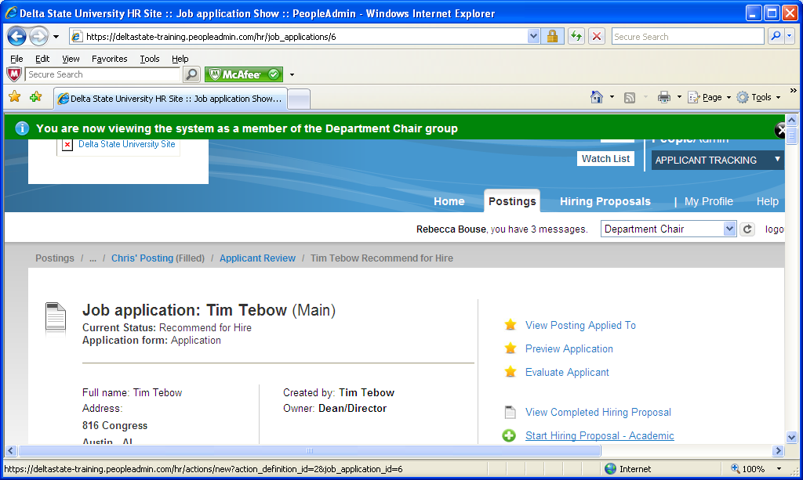

Click on Start Hiring Proposal. (Sample screenshot below)

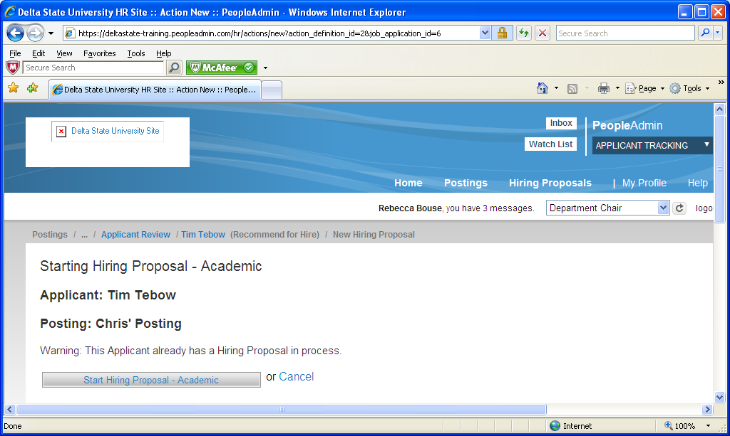
You will enter the Hiring Proposal site. Review and input Salary and Start Date. Hit the Orange next button.
You will know click on the Take Action on Hiring button and move to the next in line for approving. The last step will be to move to Human Resources. Hiring proposal must be approved by H.R. before an offer is made. (Sample screenshot below)
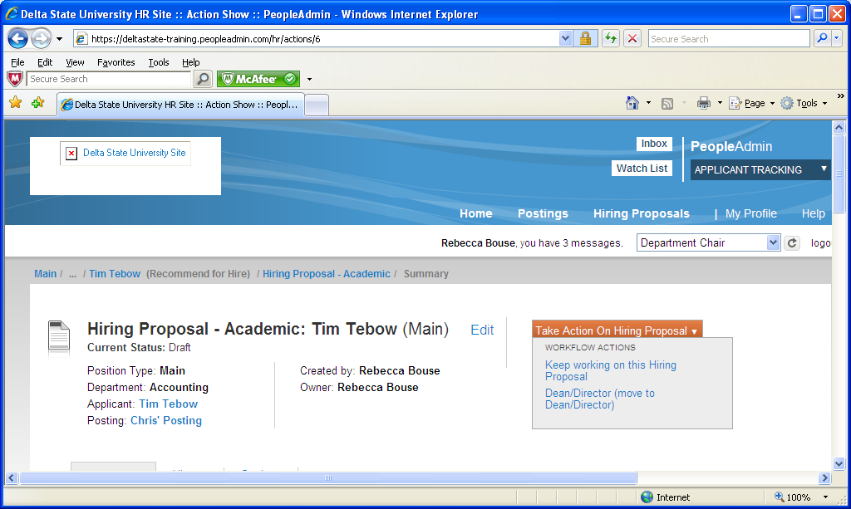
!!! Important !!!
You need take action on all other applicants by classify them as Not Interview/Not Hired or Interviewed/Not Hired. Make sure that position in moved to Filled when you are ready to close position. This will notified all candidates by email that the position has been closed and filled. By completing this action, you are completing the Recruiting Report that is necessary for all positions, and affirmative action guidelines.
REVIEW OF STEPS
- Complete posting.
- Route for approval.
- H.R. will post when position is received and approved.
- You will start receiving application directly to your posting.
- When ready to hire, start hiring proposal (Page 9)
- Hiring proposal must be approved by H.R. before you make job offer.
- When approved:
  - Do background check
  - Send offer letter
  - Submit EAF (Employment Action Form) to Human Resources
- Take action on all other candidates by classifying them as Not Interview/Not Hired or Interviewed/Not Hired.
- Move position to Filled
To access the training site to post positions: https://deltastate-training.peopleadmin.com/hr/
To access the applicant training site to apply for positions: https://deltastate-training.peopleadmin.com
(Username and Password: Both will be your user id or user name for training.)
The system has the following functions for Applicants:
It allows applicants to complete and submit an employment application online.
Applicants are able to view, update and maintain their application protected by their own logon and password.
Applicants can review the status of their employment application online at any time.
The system allows applicants to email cover letters and resumes as part of the application process.
The system provides immediate acknowledgement to applicants that their application has been received.
If unsuccessful, applicants can use the stored application to apply for future jobs at Delta State University.

