DELTA STATE UNIVERSITY

Unit Strategic Plan and Annual Report -- Academic Year 2009-10

__X__Academic Unit ____ Administrative/Support Unit

- Unit Title: Art Department

College: Arts and Sciences

Unit Administrator: Ronald G. Koehler

Program Mission:
The purposes of the Art Department are: to train teachers of art for the elementary and secondary schools, to prepare students for careers in the professional fields of art, and to offer courses to other students who wish to take art for its aesthetic and cultural values.

The Art Department will provide students with both fundamental and advanced understandings of their chosen artistic concentrations including the studies of Graphic Design, Crafts, Painting, Sculpture, and Photography.
The Art Department will develop and promote an environment of artistic achievement through presenting the broadest possible range of learning experiences for its students.
Through a diverse offering of coursework, guest artists and lecturers, field trips, class projects in the local community and other arts related learning events, the Art Department seeks to educate art students, students from across the university, and local community members in the arts and related fields.
The Art Department will support graduating students as they make the transition into professional artists and art teachers by providing information, skills, and professional guidance.

II. Educational Program Learning Outcome Assessment Plan
Learner Outcomes identified for the major.

TABLE I – Student Learning Outcomes

A. Learner Outcome  What should a graduate in the  _____(fill in major here)________  major know, value, or be able to do at graduation and beyond? | B. Data Collection & Analysis  1. What assessment tools and/or methods will you use to determine achievement of the learning outcome? 2. Describe how the data from these tools and/or methods will be/have been collected.  3.Explain the procedure to analyze the data. | C. Results of Evaluation  What were the findings of the analysis? | D. Use of Evaluation Results  1.List any specific recommendations.  2. Describe changes in curriculum, courses, or procedures that are proposed or were made/ are being made as a result of the program learning outcome assessment process.
All graduates in all art majors will demonstrate proficiency in studio art. These majors are:  - Crafts  - Graphic Design  - Painting  - Photography  - Sculpture  Proficiency is defined as the ability of a student to understand and use the vocabulary and techniques appropriate to his or her major, and to safely and effectively operate any related equipment and tools. | 1. Assessment performed via successful completion of studio projects:  a) completion of course  b) senior thesis  c) faculty-determined objectives  d) juried evaluations  e) sophomore and junior review  2. Data is collected from student portfolios, and also during sophomore and junior review.  Entering freshmen are also provided the opportunity for a portfolio review, with scholarships awarded to the most noteworthy participants. The entire faculty independently rate each applicant, and scholarships are awarded based on the highest portfolio scores.  Yearly juried student art show – visiting artist/judge awards monetary prizes with critical review to students exhibiting the greatest degree of proficiency in a gallery setting.  3. The data is analyzed in 3 ways:  - Faculty meeting with the students  - Student performance with curriculum  - Faculty evaluations | Over past several years, the large majority of oral or written comments from visiting artists/judges have been extremely positive. Only negatives: lack of equipment or need for equipment replacement in some areas.  This year 6of 6 visiting artists’ submitted formal reviews, and recommendations were provided in each major area. | Written report/commentary from visiting artists and judges recommended in addition to oral critiques.  Because of limited funds available for computers and software upgrades it was decided to require digital photography and video students to purchase Mac laptops with appropriate software and begin a gradual phasing out of computers in the digital photography lab. This was decided in a meeting with photography instructors, art department chair and the dean. This follows the computer phase out plan implemented in the graphic design computer lab in 2008 .  Recommendation approved to have a budget line for repair and replacement of equipment.
All graduates will demonstrate proficiency in art history. | Visiting artists review orally or in written form. Sophomore and junior reviews by faculty assessment team. | Over past several years large majority of oral or written comments from visiting artists/judges have been positive.  This year we had six visiting artists | Recommendation: offer a variety of new art history courses. Four new art history courses have been approved.
All graduates in the art education major will demonstrate effective procedures and methods for art instruction. | Praxis test where appropriate to analyze content acquisition and knowledge of pedagogy.  Analyze practice teaching reviews. Analyze scores on MS Teacher Assessment Instrument and the PRAXIS Test. | Over 90% success rate on MS Teacher Assessment Instrument and the PRAXIS Test.  3 of 3 students successfully completed student teaching. Over 90% success rate on MS Teacher Assessment Instrument and the PRAXIS Test. | Recommendation: create an Introduction to Art Education course to attract more students to the teaching field. Recommendation under consideration by curriculum committee.
All graduates in the graphic design major will have knowledge of the Macintosh computer platform and be fluent in layout, photo editing and illustration programs as well as have experience in web design applications. | Internship review from employer.  Visiting artist external review.  Sophomore, junior reviews and internship exit interview conducted by faculty review team.  * See Appendix I  * See Appendix II  * See Appendix III  * See Appendix IV  * See Appendix VI  * See Appendix VI | The transition of phasing out computers in the graphic design lab to students to purchasing their own Mac laptops is going well. | Six computers have been phased out at this time with six more to be removed next year.
All graduates in the photography major will develop aesthetic and technical skills that are valuable for the fields of fine art photography, filmmaking, videography, teaching, and commercial media production. | Visiting artist external review.  Sophomore and junior reviews conducted by faculty review team.  Review thesis show work by visiting artist.  Yearly juried student art show visiting artist/judge awarded scholarships with critical review. | Visiting artist/judges have been positive. Suggestion made to improve aging digital photo lab by requiring students to purchase own Mac laptop. | Recommendation approved for students to purchase their own Mac laptops with appropriate software for digital photo and video starting fall 2010.
All graduates in the painting major will be familiar and proficient in the diverse styles and methods within the painting area. | Visiting artist external review.  Sophomore and junior reviews conducted by faculty review team.  Review thesis show work by visiting artist.  Yearly juried student art show visiting artist/judge awarded scholarships with critical review. | Visiting artist/judges have been positive.
All graduates will be familiar and proficient with the diverse styles within the crafts major, including ceramics, fiber, and mixed media. | Visiting artist external review.  Sophomore and junior reviews conducted by faculty review team.  Review thesis show work by visiting artist.  Yearly juried student art show visiting artist/judge awarded scholarships with critical review. | Visiting artist/judges have been positive. Suggestion made to move weaving equipment to another room so that the fiber room could function as a larger multi-purpose room. | Recommendation implemented by moving weaving equipment and supplies to another room during summer.
All graduates in the sculpture major will be proficient in creating with a wide range of sculptural materials, techniques and methods of execution. | Visiting artist external review.  Sophomore and junior reviews conducted by faculty review team.  Review thesis show work by visiting artist.  Yearly juried student art show visiting artist/judge awarded scholarships with critical review. | Visiting artist/judges have been positive. Suggestion made to define welding area so that all combustible materials are not present. | Recommendation will be implemented with painted caution lines defining welding area. Other areas will be reconfigured.

III. Goals

-- For the Current Year

A. Goal # 1: Re-hire an Art Historian with a Ph.D.

1. Institutional Goal which was supported by this goal: SP Goal # _1_

2. Evaluation Procedure: Candidates for this position were interviewed with the most qualified candidate selected.

3. Actual Results of Evaluation: Art Historian with a Ph.D. was hired.

4. Use of Evaluation Results: This goal was achieved with the hiring of an Art Historian for fall 2009.

B. Goal #2: The fifth International Delta Film and Video Festival was held this spring and was successful. Improvements were made in the area of advertising the event. The art department will improve advertising promotional package to attract students, faculty, and community to future film festivals (6th one scheduled for April 2011).

1. Institutional Goal which was supported by this goal: SP Goal # _4_

2. Evaluation Procedure: Record of attendance will be compared to the first four Delta International Film and Video Festivals. Feedback from questionnaires and other surveys will be analyzed.

3. Actual Results of Evaluation: Submissions, attendance, sponsor involvement, and advertising efforts increased.

4. Use of Evaluation Results: Record of attendance will be used to evaluate the success of the advertising campaign. A substantial increase over previous years was recorded.

C. Goal #3: Enrich students’ cultural appreciation of art by offering trips to view art at prominent museums in Chicago, Illinois.

1. Institutional Goal which was supported by this goal: SP Goal # _1_

2. Evaluation Procedure: Exposure to art by renowned artist at major museums will greatly influence creative artistic endeavors.

3. Actual Results of Evaluation: Needed 3 more students for trip to be actualized.

4. Use of Evaluation Results: Publicize the trip more.

D. Goal #4: Update the Unit Website.

1. Institutional Goal which was supported by this goal: SP Goal # _3_

2. Evaluation Procedure: Faculty submitted information and images and reccommend further improvements to Website.

3. Actual Results of Evaluation: A new website was produced.

4. Use of Evaluation Results: Faculty recommendations improved website.

-- For Coming Year

A. Goal # 1: Provide a position for an additional Graphic Design instructor with a MFA degree.

1. Institutional Goal supported by this goal: SP Goal # _1_

2. Evaluation Procedure: Candidates for this position will be interviewed with the most qualified candidate selected when funds are available. Graphic Design is the largest area in the unit and with the implementation of the Media Arts Track more courses need to be taught.

3. Expected Results: There will be an increase in numbers with the addition of students enrolled in the media arts track.

4. Anticipated/Intended Uses of Evaluation Results: Graphic Design team currently teaching a full load. Media Arts Track will require the hiring of an additional faculty member when funds are available.

B. Goal #2: The art department will increase its faculty scholarship activities by 5% for 2010-2011 (regional and national exhibitions, publications and other creative activities.

1. Institutional Goal supported by this goal: SP Goal # 3&5_

2. Evaluation Procedure: We will compare 2009-2910 faculty scholarship activities with 2010-2011 activities.

3. Expected Results: We expect the goal to be reached.

4. Anticipated/Intended Uses of Evaluation Results: This will motivate the art department faculty to increase creative scholarship activities which in turn will positively affect their teaching.

C. Goal #3: To improve our recruitment plan, continue to participate in college recruitment nights and faculty visits to high
schools and community colleges.

- Institutional Goal supported by this goal: SP Goal # _2_

- Evaluation Procedure: Assessment of effectiveness of this goal will be measured by increases in enrollment in the art
department.

- Actual Results of Evaluation: We have seen a definite increase in students enrolling for the fall semester in the art
department because of our college night recruiting contacts. We have produced a department brochure for our recruiting activities.

- Use of Evaluation Results: Since the college recruitment nights have been successful in bringing new students to the art
department. We will continue to establish plans for student recruitment in community colleges and high schools this year..

IV. Data and information for department:

The purposes of the Art Department are to train teachers of art for the elementary and secondary schools, to prepare students for careers in the professional fields of art, and to offer courses to other students who wish to take art for its aesthetic and cultural values. Concentrations are offered in the Bachelor of Fine Arts degree, the Bachelor of Arts and the Bachelor of Arts with Educators Licensure.

 | SP 08 | SU 08 | F 08 | SP 09 | SU 09 | F 09 | SP 10
Total credit hours, undergraduate | 1938 | 210 | 1944 | 1747 | 72 | 2049 | 1785
Total credit hours, graduate | 12 | 3 | 30 | 27 | 18 | 39 | 28
Total credit hour production | 1950 | 213 | 1974 | 1774 | 90 | 4149 | 1813
Enrollment, undergraduate | 119 | 20 | 117 | 106 | 20 | 128 | 125
Enrollment, graduate | 1 | 0 | 0 | 0 | 2 | 8 | 1
Enrollment totals | 120 | 20 | 117 | 106 | 22 | 136 | 135
Grade Distribution | SP08 | SU08 | F08 | SP09 | SU 09 | F 09 | Sp 10
A | 264 | 45 | 351 | 288 | 20 | 336 | 319
B | 216 | 16 | 151 | 161 | 6 | 208 | 166
C | 75 | 8 | 73 | 66 | 2 | 87 | 67
D | 13 | 0 | 20 | 8 | 0 | 19 | 11
F | 47 | 0 | 36 | 30 | 0 | 36 | 37
W | 18 | 0 | 8 | 22 | 0 | 17 | 17
Other (I, IP, CR, AU) | 21 | 2 | 22 | 34 | 1 | 33 | 22

Advisees per faculty members - | SP 08 | F 08 | SP 09 |  | F 09 | SP 10
Abide | 26 | 18 | 19 |  | 19 | 18
Baird | 9 | 14 | 13 |  | 13 | 16
Brown | 6 | 8 | 9 |  | 9 | 6
Hein | - | 18 | 10 |  | 10 | 17
Johnston | 4 | 4 | 5 |  | 5 | 4
R. Koehler | 8 | 27 | 25 |  | 25 | 23
Melton | 26 | - | - |  | - | -
Moore | 11 | 6 | 4 |  | 4 | 7
Oguz | 5 | 7 | 5 |  | 5 | 5
K Rushing | 4 | 4 | 5 |  | 7 | 8
M Rushing | 20 | 20 | 14 |  | 12 | 18
Merryday |  |  |  |  |  | 1

 | SP 08 | SU 08 | F 08 | SP 09 | SU 09 | F 09 | SP 10
Number of graduates
BA degree | 2 | - | 2 | 1 | - | 0 | 2
BFA degree | 13 | - | 10 | 15 | - | 10 | 11
MEd, Fine Arts Education | - | - | - | 3 | - | 0 | 1
Total graduated | 15 |  | 12 | 19 | -
Writing Proficiency Exam
Credit | 5 | 1 | 4 | 1 | 0 | 4 | 3
No credit | 8 | 1 | 4 | 8 | 0 | 3 | 2

Economic Development initiatives and/or impact:
NA

Diversity Compliance Initiatives and Progress:
NA

Grants, Contracts, Partnerships, Other Accomplishments:
After-school Arts Program– Grant from Mississippi Arts Commission - Partner with Cleveland School District
Arts in the Schools – Delta Arts Alliance
Core Arts Summer Program – Partner with BPAC
Summer Arts Plus Program – Partner with BPAC
Gear Up Program – Partner with the Delta Center for Culture and Learning
Arts in April – Partner with Music Department

Committees reporting to unit:
Artists Forum Committee
Class Schedule Committee
Curriculum Committee
Delta International Film and Video Festival Committee
Exhibition Committee
Graphic Arts/Publications Committee
Meritorious Achievement Document Committee
Scholarship Committee
Sculpture Garden Committee
Student Recruiting Committee
Tenure and Promotion Committee
(Committee records Archived in the Art Department Office)

V. Personnel:
Noteworthy activities and accomplishments:

Joe Abide
Exhibited in the 2009 Crosstie Arts Festival
Exhibited in the 2009 Cottonlandia Arts Competition, Greenwood, MS
Design Delta State 2009/2010 catalog compact disc.
Judged childrens art competition at Presbyterian Day School.
Member of the Board of Directors of MERIGOLD ARTS COOPERATIVE, Merigold, Mississippi.

Duncan Baird
Exhibited in The Mississippi Invitational, Mississippi Museum of Art, Jackson, MS
Exhibited in Bright Beginnings Miniature Show, Warehouse Gallery, Cleveland, MS
Exhibited in The Professors Have It, Cottonlandia Museum, Greenwood, MS
Exhibited in the Opening Exhibition, Gallery Point Leflore, Greenwood, MS
Panelist: Art talk with Peter Plagens, Mississippi Museum of Art
Featured in article: Mississippi Yearning, by Peter Plagens, “Art in America,” November, 2009”
Program Director – Arts at Margaret Green, a community after school art program which serves students at
Margaret Green Junior High and East Side and Cleveland High School
Scholarship Committee, Kappa Pi International Art Fraternity
Donation of art work for “Bright Beginnings” fund raiser exhibition
Nominated for 2010 Visual Arts Award, Mississippi Institute of Arts and Letters

Pat Brown
Exhibited with Crosstie Faculty, Crosstie Festival, Cleveland, MS
Exhibited in 3rd Biennial Juried Invitational Exhibition, GAC, Greenville, MS. John Lawrence, Juror. Merit Award.

Exhibited work at Art Under A Hot Tin Roof, Memphis, TN
Director of Gear-Up Mississippi through Delta Center

Nathaniel Hein
Exhibited in Sculpture Key West, Key West FL, Juror: Lily Wei (International Anniversary Invitational)
Exhibited in Spctlr Vws, 1 Brooklyn Place, Brooklyn New York (Invitational)
Exhibited in Triennial Exhibition, Memphis College of Art, Memphis TN
Chair – Encountering Social Issues in Art, South Eastern College Art Conference, Mobile AL
Juror – Delta International Film Festival, Delta State University, Cleveland MS
Workshop – Collaboration and Social Action, Leadership Conference, Memphis College of Art, Memphis, TN
Established the “Plarn Project” a collaborative art project working with Art Educators and K-12 students to provide
awareness of contemporary art, environmental awareness, and collaboration (Sixteen elementary and high
schools from across the US have participated)

Ky Johnston
Exhibited in Group Exhibit, Hinds Community College, Raymond, MS
Exhibited in Summer Escape, Group Exhibit, Attic Gallery, Vicksburg, MS
Lecture and Demonstration at Jackson Academy College Fair Night, Jackson, MS
Faculty Chapter Sponsor – Kappa Pi International Honorary Art Fraternity
Founding Board Member and Arts Faculty, Merigold Arts Cooperative
Art Donations for the Institute for Community-Based Research Scholarship Fund Benefit
Art Donations for the Mississippi Hearts Against AIDS
Art Donations for the Bright Beginnings Foundation
Art Donations for the Delta Arts Alliance Annual Benefit
Art Donations for the Empty Bowls Project: A National Project to Promote Hunger Relief

Ronald Koehler
Exhibited in Arts in Harmony 2010, Arts Alliance Gallery, Elk River, MN
Exhibited in The10th International Shoebox Sculpture Exhibition, University of Hawaii, Honolulu, HI
Exhibited in Southern Appalachian Artist Guild National Juried Show, Blue Ridge, GA
Exhibited in Natchitoches Art Guild National Exhibition, Natchitoches, LA
Exhibited in Summer Escape, Attic Gallery, Vicksburg, MS
Exhibited in Greenville Arts Council 2009 Invitational, Greenville, MS
Exhibited in Goldsboro 30th Annual Juried Fine Arts Competition, Goldsboro, NC
Exhibited in Westmoreland Arts and Heritage Festival, Greensburg, PA
Exhibited in The Professors Have It, Cottonlandia Museum, Greenwood, MS
Exhibited in 44th National Juried Artist Exhibition, Covington, LA
Exhibited in Westmoreland Art National, Westmoreland County Community College, Youngwood, PA
Work appears in Wood Art Today 2, Jeffrey B. Snyder, Schiffer Books, Alglen, PA, 4 photos. p, 102 &103
Work appears in Southern Appalachian Artist Guild National Juried Show, Blue Ridge, GA, Catalog photo, p. 24 & 25
Work appears in The 10th International Shoebox Sculpture Exhibition, Catalog photo, p. 67, University of Hawaii Art Gallery,
Honolulu, HI 2009
Received $300 First Place 3-D Award, Southern Appalachian Artist Guild National Juried Show, Blue Ridge, Georgia
Received Honorable Mention 3-D Award, Southern Appalachian Artist Guild National Juried Show, Blue Ridge, GA
Received $250 Sculpture Award, 35th Westmoreland Arts and Heritage Festival, Westmoreland Community College,
Youngwood, PA
Received $100 Award of Merit, Greenville Arts Council 2009 Invitational, Greenville, MS
Juror, 44th Annual National Drawing and Small Sculpture show, Del Mar College, Corpus Christi, TX 2010
Editor, The 2010 Sketch Book, Kappa Pi International Honorary Art Fraternity Journal
Editor, The Fall 2009 Sketchpad Newsletter, Kappa Pi International Honorary Art Fraternity
Included in Who’s Who in American Art, 30th Edition, 2010
International President, Kappa Pi International Honorary Art Fraternity (since 1998) 350 chapters on college and university campuses through US and abroad

Michaela Merryday
Panelist, “Out of this World: Entr’acte: An Adventure in Avant-Garde Film and Music” Panel Discussion, Bologna
Performing Arts Center, Cleveland, MS, Spring 2010
Guest Lecturer, “Abstract Art in the Meinig Collection: From Abstract Expressionism to Post-Painterly Abstraction,”
Philbrook Museum Art, Tulsa, Summer 2009 (3 presentations)
Guest Lecturer, “Ed Ruscha and the Western Landscape,” Gilcrease Museum of Art, “From My Point of View” lecture series,
Summer 2009
Published Articles, “Westward Route 66 Takes Its Way: Ed Ruscha and the Promised Land
Organizer for guest lecturer and workshop at DSU and Merigold Arts Cooperative by Rick Lowe, Artist, Community Activist
and Founder of Project Row Houses, Houston, TX

Robyn Moore
Exhibited in 37ths Annual Meridian Museum Bi-State Art Competition (juried by Marilyn Murphey)
Exhibited in Contrast: A Visual Exploration, Juried group exhibition at The Gallery, Cleveland MS.
Exhibited in Lauren Rogers Museum of Art 30th Anniversary of the Mississippi Institute of Arts and Letters, Laurel MS.
Exhibited in Arrowmont School of Arts and Crafts Summer Faculty Exhibition, Gatlinburg TN.
Director of the Delta International Film and Video Festival (www.difvf.com)
Worked with the Merigold Arts Cooperative to create a Stop Motion Animation class collaborative project in their new space
Worked with Visiting Artist Bruce Levingston, Michaela Merryday, and Leslie Fadiga-Stewart to mount a live public
performance of Rene Clair’s 1924 short film Entr’acte titled Out of this World: An Avant-Garde Adventure in Film and Music
The Miracle of Remaining Alive, part 1 (super 8mm film to digital video transfer, 2009) screened at the Crossroads
Film Festival workshop “The Experimental South: A Roundtable of Avant-Garde/Experimental Film and
Video.” Jackson MS. Served as a speaker on this panel about experimental film in the south.
Selected as Teacher-in-Residence by the San Juan National Forest, Colorado (Summer 2009). Presented a public
workshop on Cyanotype printing. to exhibit work inspired by my residency in upcoming exhibit (Fall 2010).

Chet Oguz
Exhibited in Professors Have It, Cottonlandia Museum, Greenwood, MS
Exhibited in Crosstie Arts Festival, Cleveland, MS
Guest Lecturer, First Tuesday Presentation, Intercultural Dialogue, January 31, 2010
Perspective Drawing demonstration, Arts Festival: Nuts Over the Arts, Memphis, TN, Fall 2009,\
Guest Lecturer, History of Turkey: Religions, Culture and Economy, Presbyterian Church, Cleveland, MS

Kim Rushing
Exhibited in National Photography Exhibition, Odessa College, Odessa Texas
Collaborating with Dorothy Shawhan on book about a local outsider artist named Carolyn Norris (Univ. Press of Mississippi)
Producing book about Parchman Prison (University Press of Mississippi)
Nominated for the Mississippi Institute of Arts and Letters award for Photography

Mollie Rushing
Exhibited in Quilt and Photography, Odessa College, Odessa, Texas
“DSU First Tuesday” presentation discussing the presentation given to the Art Teachers of the Yukon Valley in
Fairbanks, AK teachers and the presentation of the same information to students in the Inuit Village of Chalkyitsik in February, 2009
Reviewer for Thames & Hudson Ltd. New Art Appreciation Textbook
Co-presenter “Compost – Just Do It” for the Cleveland Garden Club, Spring 2010
Co-presenter “The Life of Bees” for the St. Lukes Methodist YAZ group, Spring 2010

New position(s) requested, with justification:
- Hire a department secretary to replace vacated position.
This is the only secretarial position for this department. There is no one else in the department that can fill this position. The secretary is needed so that the department can function normally.
2. Provide a position for an additional Graphic Design instructor with a MFA degree.
The two graphic design faculty members are currently teaching a full load. Media Arts Track will require the hiring of an additional faculty member when funds are available (no other art faculty member on staff can teach graphic design courses).

Recommended change of status: Benjamin Ky Johnston – change status from Assistant Professor to Associate Professor of Art

VI. Degree Program Addition/Deletions and/or Major Curriculum Changes:

Changes made in the past year: New Courses were developed and offered this past year.
ART 105 – Art Exhibition: Analysis and Criticism I
ART 236 - Stop Motion Animation
ART 305 - Art Exhibition: Analysis and Criticism II
ART 306 - Papermaking
ART 339 – Advanced Web Design
ART 492 Art and Sustainability

Recommended changes for the coming year: We are waiting for the results from our NASAD accreditation vist to determine what changes definitely need to be made.

APPENDIX I

THE GRAPHIC DESIGN INTERNSHIP AS A TOOL FOR EVALUATION

As part of the curriculum for Graphic Design majors, a 240 hour internship is completed during the student’s senior year. The internship is completed at a department-approved advertising agency, printer, publisher, or other potential source of employment for graduates.

As part of the agreement between school and workplace, the place of business providing the internship agrees to give the student a measurable work load and evaluate the student’s performance in the workplace.

The student is required to keep a daily log that list the activities performed and how well the student thinks he or she is prepared to meet these assignments.

These mutual evaluations by both supervisor and student provide the department with a wealth of knowledge that not only helps us evaluate the suitability of the business for our interns but also the preparedness of our students as they exit the program and attempt to find relevant employment. We receive feedback as to the most current software in the industry as well as skill sets that are deemed valuable by employers. The student receives a valuable critique of not only technical skills but also continues to build an appreciation for factors like punctuality, constructive criticism and the importance of basic social skills in the workplace.

The Delta State University Art Department was one of the first to implement this program in our state and it continues to benefit both the Art department, the businesses involved and our graduates.

APPENDIX II DELTA STATE UNIVERSITY- ART DEPARTMENT
INTERNSHIP PROGRAM - RATING SCALE FOR INTERNS
STUDENT NAME: ID#:

COOPERATING FIRM:

COMMENCEMENT DATE: TER TERMINATION DATE:

A B C D

EXCELLENT GOOD AVERAGE POOR
1. Originality
2. Adaptability
3. Dependability
4. Ability to work with others
5. Conduct
6. Punctuality and attendance
7. Personal appearance
8. Judgment and maturity

AN EVALUATION OF INTERN’S FITNESS FOR AND PROBABLE SUCCESS IN CHOSEN FIELD

1. Do you think this intern will be a success in Design?
2. What strong points does this intern possess which would make for success in Design field?

3. List any weak characteristics or shortcomings:

4. Would you consider this intern for permanent employment on your staff? (An affirmative answer will not commit you
to employ him at any time, since that would depend on your needs and the intern’s plans for employment.)

5. Additional comments:

Please indicate the grade that, in your opinion, should be issued to this intern.

Date Grade Signed
Title

Please return this form to Ron Koehler, Chair, Dept. of Art, Box D2, Cleveland, MS 38733 PH: 662-846-4720 FAX: 662-846-4726

Appendix III

Sophomore Portfolio Review

Student

Portfolio Review Date

Art major interest: 1.

2.

3.

Areas to be discussed and reviewed:

1. Representative work and presentation

2. Quality of general art work

3. Aptitude for this field of work (Based on faculty contact in courses taken.)

4. Creativity and Content

5. Art History Writing Assignment

passed resubmit

If asked to resubmit portfolio, please come for an interview with review committee.

time date
APPENDIX IV
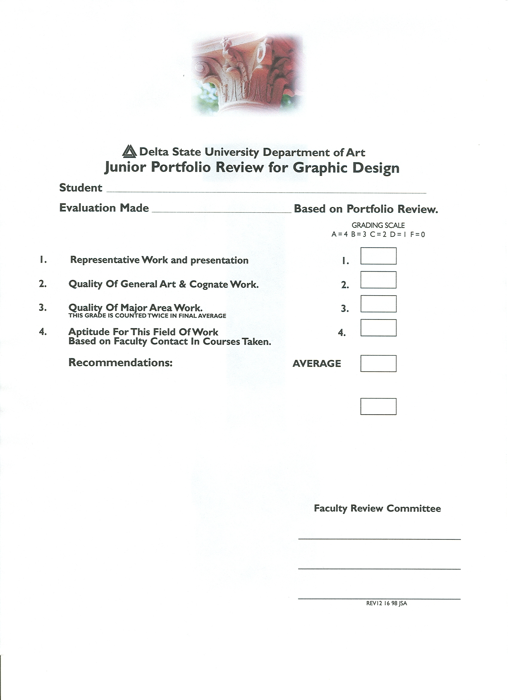

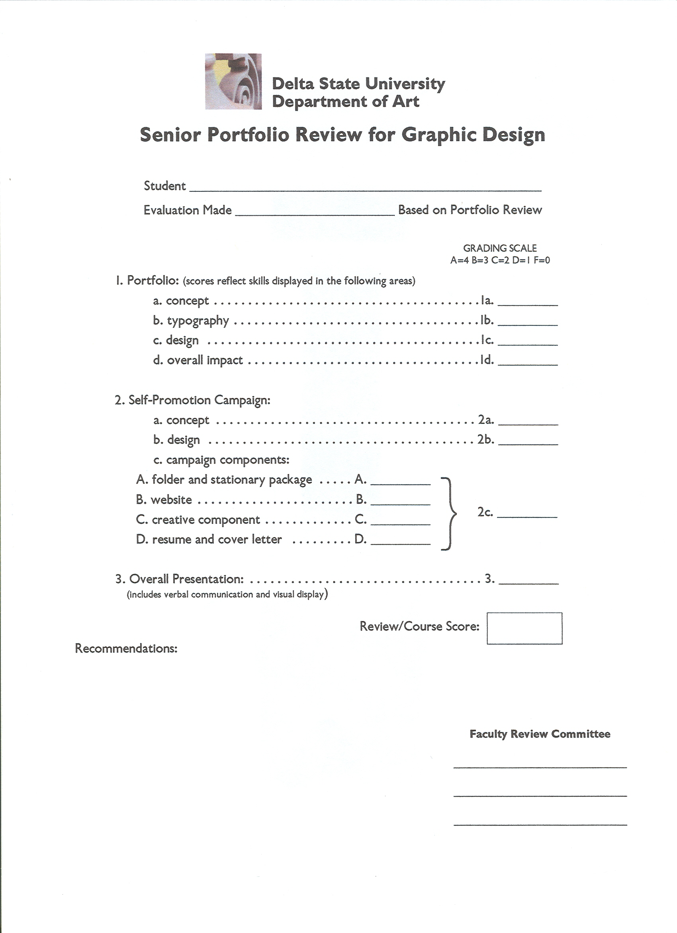
Appendix V
APPENDIX VI



